Approval Signatures:

Department | Name | Signature | Date
QA | Scott Pletzer
OPS | Michael Stowell
Exec | Nancy Rizzo
IS | Andrew Mason

Revision History
Revision | Revision Date | Reason for Revision/Change Request | Revised By
005 | 31Jul12 | Version 1.1.1.4 of the ClearView software added the ability for the system to attempt to auto-reconnect to the scanner in the situation where a connection was lost. A new section was added to the script to test this feature in the ‘Gather Capture’ section of ClearView. | A. Mason
006 | 06Sep12 | Revised to accommodate the testing requirements for the release of version 2.0. | A. Mason
007 | 11Sep12 | Made edits to the red line corrections found during the Rev.006 execution, and added an extra step in section 8.1 to test the successful calibration data save feature. | J. Sims
008 | 24Sep12 | Revised sections 9.1.3, 9.1.5, 9.1.7, 9.1.8, and 9.1.10 to completely address nonconformance #1 documented during the execution of revision 006. | S. Pletzer
009 | 24Oct12 | Change to header/footer only to reflect protocol execution for version 2.1. Removed references to old calibration process. | S. Pletzer
010 | 01Nov12 | Added table to establish initial calibration settings, updated message description for calibration failure, | S. Pletzer

- Purpose

This document is intended to provide a protocol for use in validating the ClearView ™ software. This protocol is intended to provide a method for conducting the testing as well as to be used as a formal record of the validation activities.

- Scope

This protocol is intended to be used to fully validate the CAPTURE icon portion of the ClearView software for use. The protocol can be executed in total or in part. Any deviation from performing all sections of this validation must be resolved with appropriate written justifications prior to final approval of the validation report.

- Definitions

N/A

- Responsibilities
User | - Complies with the policy and procedure.  - Ensures the most current version of this document is used when referenced.
Departmental Management | - Ensures departmental personnel are properly trained before using this policy or procedure.  - Provides oversight to the validation process and ensures that all quality system requirements are met.
Quality Assurance | - Monitors the implementation and effectiveness of this document.  - Audits to ensure compliance with the referenced procedures

- Policy
  - This protocol is intended to be updated for any changes made to the software such that the instructions provide a comprehensive test to demonstrate whether the software meets the intended use. Validation of the technical analyses and mathematical computations are completed under a separate protocol.
  - Follow the instructions provided within this protocol as written. Any deviations from the written protocol will be recorded on Attachment A, Deviations from Protocol.
    - An individual will be assigned responsibility from the Validation Team to oversee the execution of the protocol. This validation designee will review each deviation as documented prior to moving forward in the validation process.
    - The validation designee will be required to determine whether the deviation requires formal documentation through EPIC’s Deviation procedure or if the deviation is minor enough to warrant documentation only.
    - Upon completion of the protocol, the Validation Team has the responsibility to review all deviations recorded to determine whether or not they significantly impact the protocol/validation process. Any deviation deemed significant will be handled through EPIC’s Deviations procedure.
    - The individual performing the validation protocol will complete each column of Attachment A for all deviations from the written protocol prior to moving forward. The validation designee will review each deviation prior to moving forward in the validation process. This review is indicated by documenting a signature and date in the Review column of the Deviations from Protocol worksheet located in Attachment A.
    - The validation designee should be aware during the execution of this validation protocol that the intention is to validate all functionality of the CAPTURE Icon. If at any time a portion of the software is identified as not being challenged notify the validation team immediately and document the omission on the non-conformances worksheet.

  - The written protocol is intended to capture the steps needed to properly challenge each software function/data point. However, given the evolving nature of software development, the instructions may not be 100% accurate. Therefore, any minor deviation from the written instructions will be corrected in writing during the execution of the validation protocol. These corrections will be reviewed by QA as a part of the validation analysis. The review will determine appropriate corrective and preventive action for any deviations notes.

  - Record the results of each validation step by initialing and dating in the space provided. If the characteristic cannot be verified, record a reference number on the protocol and the Non-Conformances Worksheet (Attachment B) and describe the failure in a specific and complete manner by completing all columns on the Non-Conformance Worksheet. Some validation steps ask the validation designee to record the results side-by-side. In these cases, record initials and date on each side of the slash mark after validating each step as instructed.

  - ClearView Error Messages
The four acceptable error messages generated by the ClearView software are shown below. If any other error message is displayed during the execution of this protocol, describe and record the error on the Non-Conformances Worksheet.









- Procedure
  - Device Set Up
    - Verify with QA and IT that the correct ClearView software revision, license, database, and scanner have been installed on the test workstation.
    - Clean the glass lens with isopropyl alcohol and the provided cloth. Dry the glass lens completely with a separate dry cloth.
    - Place the calibration shroud over the lens cover.
    - Clean the metal cylinder of the calibration probe with isopropyl alcohol wipes. Dry the calibration probe completely with a dry cloth or tissue.
    - Place the calibration probe, metal cylinder first, through the opening of the calibration shroud until the bottom of the probe sits flat on the glass lens.
    - Double click on the ClearView software icon located on the computer desktop. This will open the ClearView software and present the “Login As” window.
    - The version of the ClearView software is displayed across the top header of the software. Record the software version being validated:
_____________________________________________

    - Login as “Administrator” and click on the “Settings” button. In the “Device Settings” section that appears, enter/verify the following values.

 | Brightness | Gain | Exposure Delay | Boost Voltage | Default
Configuration 1 | 80 | 56 | 320 | 110 % | Checked
Configuration 2 | 85 | 59 | 320 | 110 % | Unchecked
Configuration 3 | 95 | 55 | 320 | 110 % | Unchecked
Configuration 4 | 90 | 60 | 320 | 110 % | Unchecked

Note: For test scripts containing configuration settings, the values are arbitrary and may represent current device capabilities. These can be adjusted as necessary throughout the protocol to achieve desired results. Actual device settings used will be derived and evaluated from additional testing via separate protocols. Certain values (i.e., Brightness, Gain, and Exposure Delay only) may be adjusted as necessary to achieve desired test script outcome. Desired outcome may be an anticipated passing or failing calibration result, which is intended to evaluate software functionality only, not device performance.

Note: If during the execution of the protocol, the Brightness, Gain, or Exposure Delay is changed, it will be important to note the current user at the stage of the protocol when that change is required. Settings can only be changed when using the “Administrator” login. If the script has the user in a different login, the login must be changed to adjust the settings. Once the setting(s) is changed, it is important to log back in as the required test script user.

    - Click the “Apply Settings” button and exit out of ClearView.

  - “Login As” function- This window provides the user a method to enter their user name and password in order to access the ClearView software application.

Double click on the ClearView icon located on the computer desktop. Verify that the Username and Password box are empty.

Verified Not Verified Non-Conformance Ref. No.

Click in the Username box and enter “EPICUser”. Click in the password box and enter the password provided by the Network Administrator. Click the Cancel button. Verify that the “Login As” window and the ClearView software window close and returned to the computer desktop.

Verified Not Verified Non-Conformance Ref. No.

Double click on the ClearView software icon located on the computer desktop. Click in the Username box and enter “EPICUser”. Click in the password box and enter the password provided by the Network Administrator. Click the Login button. Verify that the “Login As” window is closed and EPIC ClearView main screen for the ClearView software is displayed.

Verified Not Verified Non-Conformance Ref. No.

NOTE: Calibration must be completed prior to proceeding with the validation. Calibration Icon is validated in a different portion of this protocol.
Calibration instructions- This section would only be performed if the device had not yet been calibrated during separate testing.
In the ClearView™ software, click on Camera Calibration.
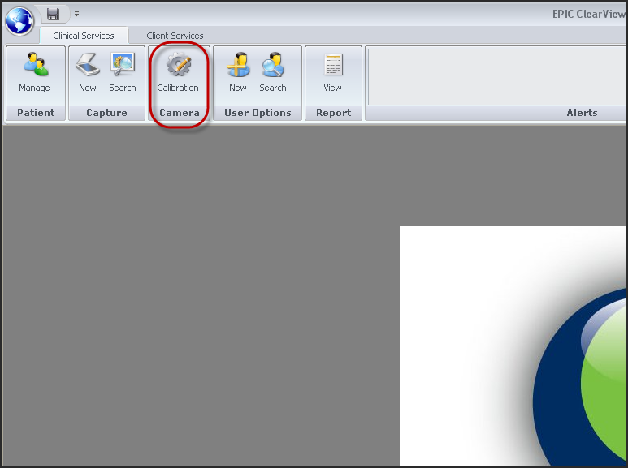
The Scanner Calibration window will open. Click the Auto Calibration button in the lower right corner of the window.

The ClearView™ device will make a “beep” sound and will capture five warm-up images and ten calibration images, one after the other.
Do not touch the ClearView™ device, the USB cable, or the calibration probe during image capture at any time.
After all ten (10) images are automatically captured; the ClearView™ software will start analyzing the calibration images. If the calibration images pass, the next screen will return a message indicating the calibration process was successful. Click OK to close the message window and Close to leave the Calibration Tab.
If calibration fails, you will receive an error message that says “Unable to verify calibration. Please, repeat calibration process.” Click OK to leave the Calibration Tab.
The ClearView™ software will only allow you to continue on to patient image capture if the calibration images have passed calibration testing. If calibration testing has not passed, try the following steps:
- Re-clean the glass surface and metal piece of the calibration probe.
  - Dry the glass surface and metal piece completely with the provided cleaning supplies, ensuring that no debris, lint, or oil remains.
  - Make sure to not touch the metal piece of the calibration probe with your fingers.
- Ensure that the metal piece of the calibration probe fits snugly through the calibration cover and lays flat on the glass surface.
- Ensure that the testing surface is level.

NOTE: The ClearView software is divided into three levels: tabs, subtabs, and categories. These levels will be referenced throughout this document. 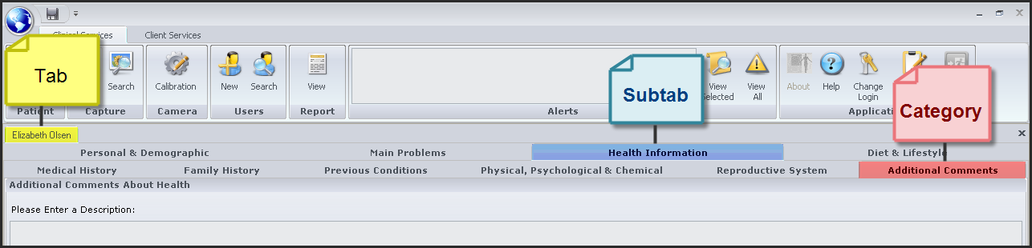

  - New Capture icon. The Capture button has two sections – New and Search.

From the EPIC ClearView main screen, click on the New Capture icon. Verify that the Search Patient window appears.

Verified Not Verified Non-Conformance Ref. No.

Search Patient Find function:
With all entry fields blank or null, click the Find button. Verify that a list of patients with various last names, first names, gender, and Patient ID is displayed:

Verified Not Verified Non-Conformance Ref. No.

Enter the patient’s last name of NJMAA. Click the Find button. Verify that a patient by the last name of NJMAA is not displayed and record the result:

Result

Verified Not Verified Non-Conformance Ref. No.

Delete any previous entry. Enter the patient’s last name as Validation and click Find. Verify that only patients with the last name of Validation are displayed and record the result:

Result
Result
Result
Result
Result
Result

Verified Not Verified Non-Conformance Ref. No.

Delete any previous entry. Enter the patient’s last name as O and click Find. Verify that only patients with last names beginning with O are displayed and record the result:
Result
Result
Result
Result
Result
Result
Result

Verified Not Verified Non-Conformance Ref. No.

Highlight and delete the “o” in the last name box.
Enter the patient’s first name of NJMAA (last name box should be blank). Click the Find button. Verify that a patient by the first name of NJMAA is not displayed and record the result:

Result

Verified Not Verified Non-Conformance Ref. No.

Delete any previous entry. Enter the patient’s first name as Epic and click Find. Verify that only patients with the first name of Epic are displayed and record the result:

Result
Result
Result
Result
Result
Result
Result

Verified Not Verified Non-Conformance Ref. No.

Delete any previous entry. Enter the patient’s first name as E and click Find. Verify that only patients with a first name beginning with E are displayed and record the result:

Result
Result
Result
Result
Result
Result
Result
Result
Result
Result
Result
Result
Result
Result
Result
Result

Verified Not Verified Non-Conformance Ref. No.

Highlight and delete the “e” from the first name box. The Gender field is a drop down menu. With all other entry fields blank, select the Gender as Female by either clicking on the arrow to the right of the field to open the menu and select the correct gender or by clicking in the box which automatically displays the drop down box. Type “F” and click Enter to select Female, then click on the Find button. Verify that a list of female patients is displayed (no male patients listed):

Verified Not Verified Non-Conformance Ref. No.

With all other entry fields blank, select the Gender as Male by either clicking on the arrow to the right of the field to open the menu and select the correct gender or by clicking in the box which automatically displays the drop down box. Type “M” and click Enter to select male then click Find. Verify that a list of Male patients is displayed (no female patients listed):

Verified Not Verified Non-Conformance Ref. No.

With all other entry fields blank, select the Gender as Not Selected by either clicking on the arrow to the right of the field to open the menu and select the correct gender or by clicking in the box which automatically displays the drop down box. Type “N” and click Enter to select Not Selected. Click Find. Verify that a list of Male and Female patients is displayed:

Verified Not Verified Non-Conformance Ref. No.

Click the “x” in the upper right corner of the Search Patient window. Verify that the window is closed and you are returned to the main screen.

Verified Not Verified Non-Conformance Ref. No.

From the EPIC ClearView main screen, click on the New Capture icon. The Search Patient window appears.

With all other entry fields blank, enter a birth date of 05/13/1951 and click the Find button. Verify that a list of patients with a birth date of 05/13/1951 (slashes are required) is displayed (no patients listed with any other birth date) by opening all patients listed and verifying the birthdate entered. Note: If you view a patient to verify the correct Birthday, you will be required to return to the Search Patient screen in order to verify the remainder of the Birthdays.

Verified Not Verified Non-Conformance Ref. No.

With all other entry fields blank, enter a birth date of 11/18/1969 and click the Find button. Verify that a list of patients with a birth date 11/18/1969 (slashes are required) is displayed (no patients listed with any other birth date) by opening all patients listed and verifying the birthdate entered.

Verified Not Verified Non-Conformance Ref. No.

Click the “x” in the upper right corner of the Search Patient Screen. From the EPIC ClearView main screen, click on the New Capture icon. The Search Patient window appears. With all other entry fields blank, enter a birth date as “A” only. Verify that all patients appear (invalid birth date results in a null entry and displays all patients).

Verified Not Verified Non-Conformance Ref. No.

Click the “X” in the upper right corner of the search patient screen.

  - New Capture - New Patient button.

Click the Capture New icon. The Search Patient window will open. Click the Find button. Verify that the New Patient button appears in the lower right corner of the Search Patient window. Click the New Patient button. Verify that the Search Patient window closes and a new screen appears with the Demographics tab open.

Verified Not Verified Non-Conformance Ref. No.

General Info Section
Type the following into the appropriate locations:

First Name Clear
Mi (middle initial) O
Last Name ViewXXXc (where XXX represents the version number being validated and the c represents the Capture module)
Birth Date 11/25/1978
Gender Male

Click the “X” in the upper right corner of the Patient Demographics tab. Click “No”. Save the data by clicking the Save icon in the upper left corner of the screen. Verify that a message indicating the patient was saved is displayed. Click OK. Click the “X” in the upper left corner of the Demographics tab. Verify that the Patient Demographics tab closes and that the screen is returned to the Main Screen.

Verified Not Verified Non-Conformance Ref. No.

New Capture – User Login
Click on the New Capture button. Verify that the Search Patient window opens. Click the Find button at the top of the displayed window. Search and identify patient Epic Validation. Click to highlight this patient and click the New Capture button in the lower right corner of the window. Verify that the Pre-Scan Question dialog appears.

Verified Not Verified Non-Conformance Ref. No.

Click the Cancel button on the Pre-Scan Question dialog and verify that the Pre-Scan Question dialog closes and the user is returned to the ClearView main screen.

Verified Not Verified Non-Conformance Ref. No.

Click on the New Capture button. Verify that the Search Patient window opens. Click the Find button at the top of the displayed window. Search and identify patient Epic Validation. Click to highlight this patient and click the New Capture button in the lower right corner of the window. Verify that the Pre-Scan Question dialog appears.

Verified Not Verified Non-Conformance Ref. No.

Click the OK button on the Pre-Scan Question dialog and verify that a Missing Data error message appears. Click OK to close error message.

Verified Not Verified Non-Conformance Ref. No.

Answer any 2 of the 3 questions and click the OK button on the Pre-Scan Question dialog and verify that a Missing Data error message appears. Click OK to close error message.

Verified Not Verified Non-Conformance Ref. No.

Answer all 3 questions with “NO” and click the OK button on the Pre-Scan Question dialog and verify that the Gather Capture screen appears. Click Close button in the lower right corner, answer YES to the question that appears, and verify the window closes and the user is returned to the ClearView main screen.

Verified Not Verified Non-Conformance Ref. No.

Click on the New Capture button. Verify that the Search Patient window opens. Click the Find button at the top of the displayed window. Search and identify patient Epic Validation. Click to highlight this patient and click the New Capture button in the lower right corner of the window. Verify that the Pre-Scan Question dialog appears.

Verified Not Verified Non-Conformance Ref. No.

Answer all 3 questions with “YES” and click the OK button on the Pre-Scan Question dialog and verify that the Gather Capture screen appears.
Verified Not Verified Non-Conformance Ref. No.

Verify that the Submit for Analysis button in the lower right corner of the window is inactive. Verify that the Capture Image and Close buttons are active.

Verified Not Verified Non-Conformance Ref. No.

Click into the right thumb finger box. Verify that an image appears in the Finger Image box. Verify Right Thumb Finger appears in red and 1R label appears in the hands box. Verify that the System Messages box reads “Note: Verify that there is not a capacitive barrier in the scanner.”

Verified Not Verified Non-Conformance Ref. No.

Click on the Capture Image button in the lower right corner of the window. Verify that an image appears in the Captured Image window and Right Thumb Finger window in the Images without Capacitive Barrier row.

Verified Not Verified Non-Conformance Ref. No.

Click into the Right Index Finger box of the Images without Capacitive Barrier row. Verify that an image appears in the Finger Image box. Verify that Right Index Finger appears in red and 2R label appears in the hands box. Click the Capture Image button. Verify that the image appears in the Captured Image window and in the Right Index Finger window in the Images without Capacitive Barrier row.

Verified Not Verified Non-Conformance Ref. No.

Click into the Right Middle Finger box of the Images without Capacitive Barrier row. Verify that an image appears in the Finger Image box. Verify that Right Middle Finger appears in red and 3R label appears in the hands box. Click the Capture Image button. Verify that the image appears in the Captured Image window and in the Right Middle Finger window in the Images without Capacitive Barrier row.

Verified Not Verified Non-Conformance Ref. No.

Click into the Right Ring Finger box of the Images without Capacitive Barrier row. Verify that an image appears in the Finger Image box. Verify that Right Ring Finger appears in red and 4R label appears in the hands box. Click the Capture Image button. Verify that the image appears in the Captured Image window and in the Right Ring Finger window in the Images without Capacitive Barrier row.

Verified Not Verified Non-Conformance Ref. No.

Click into the Right Pinky Finger box of the Images without Capacitive Barrier row. Verify that an image appears in the Finger Image box. Verify that Right Pinky Finger appears in red and 5R label appears in the hands box. Click the Capture Image button. Verify that the image appears in the Captured Image window and in the Right Pinky Finger window in the Images without Capacitive Barrier row.

Verified Not Verified Non-Conformance Ref. No.

Click into the Left Thumb Finger box of the Images without Capacitive Barrier row. Verify that an image appears in the Finger Image box. Verify that Left Thumb Finger appears in red and 1L label appears in the hands box. Click the Capture Image button. Verify that the image appears in the Captured Image window and in the Left Thumb Finger window in the Images without Capacitive Barrier row.

Verified Not Verified Non-Conformance Ref. No.

Click into the Left Index Finger box of the Images without Capacitive Barrier row. Verify that an image appears in the Finger Image box. Verify that Left Index Finger appears in red and 2L label appears in the hands box. Click the Capture Image button. Verify that the image appears in the Captured Image window and in the Left Index Finger window in the Images without Capacitive Barrier row.

Verified Not Verified Non-Conformance Ref. No.

Click into the Left Middle Finger box of the Images without Capacitive Barrier row. Verify that an image appears in the Finger Image box. Verify that Left Middle Finger appears in red and 3L label appears in the hands box. Click the Capture Image button. Verify that the image appears in the Captured Image window and in the Left Middle Finger window in the Images without Capacitive Barrier row.

Verified Not Verified Non-Conformance Ref. No.

Click into the Left Ring Finger box of the Images without Capacitive Barrier row. Verify that an image appears in the Finger Image box. Verify that Left Ring Finger appears in red and 4L label appears in the hands box. Click the Capture Image button. Verify that the image appears in the Captured Image window and in the Left Ring Finger window in the Images without Capacitive Barrier row.

Verified Not Verified Non-Conformance Ref. No.

Click into the Left Pinky Finger box of the Images without Capacitive Barrier row. Verify that an image appears in the Finger Image box. Verify that Left Pinky Finger appears in red and 5L label appears in the hands box. Click the Capture Image button. Verify that the image appears in the Captured Image window and in the Left Pinky Finger window in the Images without Capacitive Barrier row.

Verified Not Verified Non-Conformance Ref. No.

Click into the Right Thumb Finger box of the Images without Capacitive Barrier row. Verify a previously captured energized image appears in the Right Thumb Finger box in the Images without Capacitive Barrier Row. Verify that Right Thumb Finger appears in red and 1R label appears in the hands box. Click the Capture Image button. Verify that the image displayed in the Captured Image window changes and in the Right Thumb Finger window in the Images without Capacitive Barrier row.

Verified Not Verified Non-Conformance Ref. No.

Click into the Right Index Finger box of the Images without Capacitive Barrier row. Verify that a previously captured image appears in the Captured Image box. Verify that Right Index Finger appears in red and 2R label appears in the hands box. Click the Capture Image button. Verify that the image displayed in the Captured Image window changes and in the Right Index Finger window in the Images without Capacitive Barrier row.

Verified Not Verified Non-Conformance Ref. No.

Click into the Right Middle Finger box of the Images with Capacitive Barrier row. Verify that an image appears in the Captured Image box. Verify that Right Middle Finger appears in red and 3R label appears in the hands box. Click the Capture Image button. Verify that the image appears in the Captured Image window and in the Right Middle Finger window in the Images with Capacitive Barrier row.

Verified Not Verified Non-Conformance Ref. No.

Click into the Right Ring Finger box of the Images with Capacitive Barrier row. Verify that an image appears in the Captured Image box. Verify that Right Ring Finger appears in red and 4R label appears in the hands box. Click the Capture Image button. Verify that the image appears in the Captured Image window and in the Right Ring Finger window in the Images with Capacitive Barrier row.

Verified Not Verified Non-Conformance Ref. No.

Click into the Right Pinky Finger box of the Images with Capacitive Barrier row. Verify that an image appears in the Captured Image box. Verify that Right Pinky Finger appears in red and 5R label appears in the hands box. Click the Capture Image button. Verify that the image appears in the Captured Image window and in the Right Pinky Finger window in the Images with Capacitive Barrier row.

Verified Not Verified Non-Conformance Ref. No.

Click into the Left Thumb Finger box of the Images with Capacitive Barrier row. Verify that an image appears in the Captured Image box. Verify that Left Thumb Finger appears in red and 1L label appears in the hands box. Click the Capture Image button. Verify that the image appears in the Captured Image window and in the Left Thumb Finger window in the Images with Capacitive Barrier row.

Verified Not Verified Non-Conformance Ref. No.

Click into the Left Index Finger box of the Images with Capacitive Barrier row. Verify that an image appears in the Captured Image box. Verify that Left Index Finger appears in red and 2L label appears in the hands box. Click the Capture Image button. Verify that the image appears in the Captured Image window and in the Left Index Finger window in the Images with Capacitive Barrier row.

Verified Not Verified Non-Conformance Ref. No.

Click into the Left Middle Finger box of the Images with Capacitive Barrier row. Verify that an image appears in the Captured Image box. Verify that Left Middle Finger appears in red and 3L label appears in the hands box. Click the Capture Image button. Verify that the image appears in the Captured Image window and in the Left Middle Finger window in the Images with Capacitive Barrier row.

Verified Not Verified Non-Conformance Ref. No.

Click into the Left Ring Finger box of the Images with Capacitive Barrier row. Verify that an image appears in the Captured Image box. Verify that Left Ring Finger appears in red and 4L label appears in the hands box. Click the Capture Image button. Verify that the image appears in the Captured Image window and in the Left Ring Finger window in the Images with Capacitive Barrier row.

Verified Not Verified Non-Conformance Ref. No.

Click into the Left Pinky Finger box of the Images with Capacitive Barrier row. Verify that an image appears in the Captured Image box. Verify that Left Pinky Finger appears in red and 5L label appears in the hands box. Click the Capture Image button. Verify that the image appears in the Captured Image window and in the Left Pinky Finger window in the Images with Capacitive Barrier row.

Verified Not Verified Non-Conformance Ref. No.

Click on the Right Ring Finger box in the Images without Capacitive Barrier row. Click the Capture Image button. Verify that a new image appears in the Captured Image window and in the Right Ring Finger window in the Images without Capacitive Barrier row.

Verified Not Verified Non-Conformance Ref. No.

Click on the Right Thumb Finger box in the Images with Capacitive Barrier row. Click the Capture Image button. Verify that a new image appears in the Captured Image window and in the Right Thumb Finger window in the Images with Capacitive Barrier row.

Verified Not Verified Non-Conformance Ref. No.

Repeat this step for the Right index finger box in the Images with Capacitive Barrier row.

Verified Not Verified Non-Conformance Ref. No.

Click on the Left Middle Finger box in the Images with Capacitive Barrier row. Click the Capture Image button. Verify that an image appears in the Captured Image window and in the Left Middle Finger window in the Images with Capacitive Barrier row.

Verified Not Verified Non-Conformance Ref. No.

When all twenty images are displayed in the Images without Capacitive Barrier Row and the Images with Capacitive Barrier Row, verify that the Submit for Analysis button in the lower right corner of the window is active.

Verified Not Verified Non-Conformance Ref. No.

Click to uncheck the Show Axis/Angle box under the Finger Image box. Verify that the red crosshairs and yellow circle disappear. Click again to check and verify that the crosshairs and yellow circle reappear.

Verified Not Verified Non-Conformance Ref. No.

Click into the Right Thumb Finger box of the Images without Capacitive Barrier row. Under the Captured Image box, next to Angle, click the green clockwise arrow button ten times and verify that the crosshairs rotate 10 degrees clockwise in the Captured Image box and “10” appears in the Angle display box.

Verified Not Verified Non-Conformance Ref. No.

Click into the Right Index Finger box of the Images without Capacitive Barrier row. Under the Captured Image box, next to Angle, click the green counter-clockwise arrow button five times and verify that the crosshairs rotate 5 degrees counter-clockwise in the Captured Image box and “-5” appears in the Angle display box.

Verified Not Verified Non-Conformance Ref. No.

Click into the Right Middle Finger box of the Images without Capacitive Barrier row. Under the Captured Image box, next to X, click the green left arrow button five times and verify that the circle and crosshairs move 5 increments to the left along the x axis in the Captured Image box and decreases 5 points in the X display box.

Verified Not Verified Non-Conformance Ref. No.

Click into the Right Ring Finger box of the Images without Capacitive Barrier row. Under the Captured Image box, next to X, click the green right arrow button ten times and verify that the circle and crosshairs move 10 increments to the right along the x axis in the Captured Image box and increases 10 points in the X display box.

Verified Not Verified Non-Conformance Ref. No.

Click into the Right Pinky Finger box of the Images without Capacitive Barrier row. Under the Captured Image box, next to Y, click the green up arrow button ten times and verify that the circle and crosshairs move 10 increments up along the y axis in the Captured Image box and increases 10 points in the Y display box.

Verified Not Verified Non-Conformance Ref. No.

Click into the Left Thumb Finger box of the Images without Capacitive Barrier row. Under the Captured Image box, next to Y, click the green down arrow button five times and verify that the circle and crosshairs move 5 increments down along the y axis in the Captured Image box and decreases 5 points in the Y display box.

Verified Not Verified Non-Conformance Ref. No.

Click into the Right Thumb Finger box of the Images with Capacitive Barrier row. Under the Captured Image box, next to Angle, click the clockwise button ten times, next to X, click the left arrow ten times, and next to Y, click the green up arrow button ten times and verify that the circle and crosshairs moved 10 increments in the correct direction and in the display boxes.

Verified Not Verified Non-Conformance Ref. No.

Click into the Left Pinky Finger box of the Images with Capacitive Barrier row. Under the Captured Image box, next to Angle, click the counter-clockwise button five times, next to X, click the right arrow five times, and next to Y, click the green down arrow button five times and verify that the circle and crosshairs moved 5 increments in the correct direction and in the display boxes.

Verified Not Verified Non-Conformance Ref. No.

Click on any Finger image in the Images without Capacitive Barrier row. Verify that the System Messages box under the hands box reads “Note: Verify that there is not a capacitive barrier in the scanner”.

Verified Not Verified Non-Conformance Ref. No.

Click on any Finger image in the Images with Capacitive Barrier row. Verify that the System Messages box under the hands box reads “Note: Verify that there is a capacitive barrier in the scanner”.

Verified Not Verified Non-Conformance Ref. No.

Click the Close button in the lower right corner of the window. Verify the Exit Process dialog box opens to confirm exit. Click the No button. Verify that the “Gather a capture for” window stays open and that all captured images are displayed as previous displayed prior to clicking the Close button.

Verified Not Verified Non-Conformance Ref. No.

Click the Close button in the lower right corner of the window. Verify the Exit Process dialog box opens to confirm exit. Click the Yes button. Verify that the “Gather a capture for” window closes and the screen returns to the EPIC ClearView main screen.

Verified Not Verified Non-Conformance Ref. No.

Click on the New Capture button. Verify that the Search Patient window opens.
Click the Find button at the top of the displayed window. Search and identify patient Epic Validation. Click to highlight this patient and click the New Capture button in the lower right corner of the window. Verify that the Pre-Scan Question dialog appears.

Verified Not Verified Non-Conformance Ref. No.

Answer all 3 questions with “NO” and click the OK button on the Pre-Scan Question dialog and verify that the Gather Capture screen appears.

Verified Not Verified Non-Conformance Ref. No.

Verify that the Submit for Analysis button in the lower right corner of the window is inactive. Verify that the Capture Image and Close buttons are active.

Verified Not Verified Non-Conformance Ref. No.

Capture a full set of subject images by clicking into each finger image box of the Images without Capacitive Barrier row. Click the Capture Image button. Repeat the process until 10 Images without Capacitive Barrier and 10 Images with Capacitive Barrier have been captured. Verify that all twenty Images without Capacitive Barrier and Images with Capacitive Barrier image boxes contain energized images.

Verified Not Verified Non-Conformance Ref. No.

Click on each energized image box (both Images without Capacitive Barrier and Images with Capacitive Barrier). Verify that the displayed energized image and displayed finger image change after clicking on a different image box. Repeat until all twenty images have been clicked.

Verified Not Verified Non-Conformance Ref. No.

Click on the Submit for Analysis button in the lower right corner of the window. Verify that the processing window appears and a spinning graphic as well as text stating the function being performed appears. After processing, verify that a new screen displays with the Report for Patient Name tab highlighted.

Verified Not Verified Non-Conformance Ref. No.

Click on the tab labeled “Print Report For Patient Name” and verify it is five pages, page 1 contains explanations and Table 1, pages 2, 3 and 4 display Table 2 (containing organs and scores in the following order of Organ Systems: Sensory and Skeletal; Hepatic, Cardiovascular; Respiratory; Gastrointestinal & Endocrine; and Renal and Reproductive Systems), and page 5 contains definitions.

Verified Not Verified Non-Conformance Ref. No.

Click on the tab labeled “Report For Patient Name”. Click on the inner tab labeled “System Comparison”. Verify that a new screen appears with two boxes containing body side views, graphs, and organ names.

Verified Not Verified Non-Conformance Ref. No.

Click the “X” in the upper right corner of each tab. Verify each tab closes and the screen returns to the EPIC ClearView main screen.

Verified Not Verified Non-Conformance Ref. No.

NOTE: The validation of the System Comparison tab, Bio-fields tab, Print Report tab, and Report for Patient Name tab are performed as a separate validation(s).

  - New Capture - Administrator Login

Click on the Change Login icon at the top of the screen. Login as “Administrator” with the password provided by the Network Administrator. Click on the New Capture button. Verify that the Search Patient window opens.

Verified Not Verified Non-Conformance Ref. No.

Click the Find button at the top of the displayed window. Search and identify patient Epic Validation. Click to highlight this patient and click the New Capture button in the lower right corner of the window. Verify that the Pre-Scan Question dialog box opens.

Verified Not Verified Non-Conformance Ref. No.

Answer all 3 questions with “NO” and click the OK button on the Pre-Scan Question dialog and verify that the Gather Capture screen appears.

Verified Not Verified Non-Conformance Ref. No.

Verify that the Submit for Analysis button in the lower right corner of the window is inactive. Verify that the Capture Image and Close buttons are active. Verify that the Export Images button in the lower left corner of the window is active.

Verified Not Verified Non-Conformance Ref. No.

Capture a full set of subject images by clicking into each finger image box of the Images without Capacitive Barrier row. Click the Capture Image button. Repeat the process until 10 Images without Capacitive Barrier and 10 Images with Capacitive Barrier have been captured. Verify that all twenty Images without Capacitive Barrier and Images with Capacitive Barrier image boxes contain energized images. Note: calibration images should not be used as they may cause a matlab error, therefore, human subject images should be used.

Verified Not Verified Non-Conformance Ref. No.

Click the Live Preview button to deactivate Live Preview. Click on each energized image box (both Images without Capacitive Barrier and Images with Capacitive Barrier). Verify that the displayed energized image and displayed finger image change after clicking on a different image box. Repeat until all twenty images have been clicked.

Verified Not Verified Non-Conformance Ref. No.

Click on the Export Images button. Verify that the Browse for Folder window opens. Locate folder O:\QualitySystems\Quality_System_Documents\Non-quality_system_records\ClearView_Validation\ExportImages. Click OK. Verify the ClearView dialog box opens with the message “Images have been successfully saved.” Click OK and verify that the dialog box closes.

Verified Not Verified Non-Conformance Ref. No.

Click the “-” in the upper right corner of the ClearView main screen to minimize ClearView and to display the Desktop. Click on My Computer and locate folder O:\QualitySystems\Quality_System_Documents\Non-quality_system_records\ClearView_Validation\ExportImages. Verify that there are 40 images in the folder.

Verified Not Verified Non-Conformance Ref. No.

Maximize the ClearView screen from the taskbar. Click on the Submit for Analysis button in the lower right corner of the window. Verify that the processing window appears and a spinning graphic as well as text stating the function being performed appears. After processing, verify that a new screen displays with the Report for Patient Name tab highlighted. Click on the tab labeled Print Report For Patient Name.

Verified Not Verified Non-Conformance Ref. No.

Verify the report is five pages, page 1 contains explanations and Table 1, pages 2, 3 and 4 display Table 2 (containing organs and scores in the following order of Organ Systems: Sensory and Skeletal; Hepatic, Cardiovascular; Respiratory; Gastrointestinal & Endocrine; and Renal and Reproductive Systems), and page 5 contains definitions.

Verified Not Verified Non-Conformance Ref. No.

Click on the Biofield Analysis tab. Verify that a new screen appears with the Item Tab displayed on the left containing boxes for Indexes, Organ Systems, and Settings, a Magnified View tab (open) and an Admin View tab, and a visual representation of the body views.

Verified Not Verified Non-Conformance Ref. No.

Click on the Admin pages tab. Verify that the Raw Data sub tab is highlighted and a worksheet is displayed containing multiple columns and rows of data. Verify that the individual cells cannot be modified.

Verified Not Verified Non-Conformance Ref. No.

Click on the Raw Report Data sub tab. Verify that a worksheet is displayed with two tables containing multiple columns and rows of data. Verify that the individual cells cannot be modified.

Verified Not Verified Non-Conformance Ref. No.

Click on the Images without Capacitive Barrier sub tab. Verify that 10 scan images are displayed, labeled “Images without Capacitive Barrier”.

Verified Not Verified Non-Conformance Ref. No.

Click on the Toggle Sectors button in the lower left corner of the screen below the Images without Capacitive Barrier. Verify that the sector lines appear on each image. Click on the Toggle Sectors button again and verify that the sector lines disappear.

Verified Not Verified Non-Conformance Ref. No.

Click on the Images with Capacitive Barrier sub tab. Verify that 10 scan images are displayed, labeled “Images with Capacitive Barrier”.

Verified Not Verified Non-Conformance Ref. No.

Click on the Toggle Sectors button in the lower left corner of the screen below the Images with Capacitive Barrier. Verify that the sector lines appear on each image. Click on the Toggle Sectors button again and verify that the sector lines disappear.

Verified Not Verified Non-Conformance Ref. No.

Click on the Calibration Data sub tab, verify that 10 calibration images appear labeled Calibration Image #1 through Calibration Image #10 appear.

Verified Not Verified Non-Conformance Ref. No.

Click on the Report For Patient Name tab, then click on the System Comparison sub tab. Verify that a new screen appears with two boxes containing body side views, graphs, and organ names.

Verified Not Verified Non-Conformance Ref. No.

Click ‘X’ in the upper right corner of the screen until you return to the ClearView main screen.

NOTE: The validation of the System Comparison tab, Admin pages, Bio-fields tab, Report For Patient Name tab, and the Print Report tab are performed as a separate validation(s).

  - View Patient button.

Click on the Change Login icon at the top of the screen. Login as “EPICUser” with the password provided by the Network Administrator.

Click on the New Capture button. Verify that the Search Patient window opens. Enter “Val” in the First Name box. Click Find. Click to highlight patient name “Val Sample1” and click the View Patient button in the lower right corner of the window. Verify that the View Patient tab screen opens and appears as shown below and verify all fields with input data. Note: Age increasing from that shown is acceptable as the Age shown below is relative to when this protocol was created.

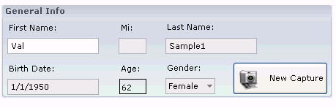

Verified Not Verified Non-Conformance Ref. No.

Click the “X” in the upper right corner of the View Patient tab. Verify that the tab closes and the screen returns to the EPIC ClearView main screen.

Verified Not Verified Non-Conformance Ref. No.

  - Search Capture

This button is used to search for previous treatments. Close all open Tabs. Verify that the system returned to the EPIC ClearView main screen.

Verified Not Verified Non-Conformance Ref. No.

From the EPIC ClearView main screen, click on the Search Capture icon. Verify that the Search Capture window appears.

Verified Not Verified Non-Conformance Ref. No.

Search Capture Find function:
With all entry fields blank or null, click the Find button. Verify that a list of patients with columns for Patient Name, Treatment ID, Version, Run Notes, Scan Type, Scan Date, and Archived, is displayed.

Verified Not Verified Non-Conformance Ref. No.

    - Select three (3) different Patient Names and record the name, Treatment ID, and Scan Date below (include one resubmit ID):
Result 1
Result 2
Result 3
Click X on the Search Capture Screen.
    - Click on the Change Login icon at the top of the screen. Login as “Administrator” with the password provided by the Network Administrator. Find and click the “View Report” button for the 3 patient names identified above. Click on the Admin Pages tab to open the Raw Data tab. After processing, the ClearView Report screen will open. Locate the name from the Admin Pages tab (name follows Admin Pages for), locate the PatientTreatmentId column, and locate the DateAnalysed column and record the results below:

Result 1
Result 2
Result 3

Verify that the results match the entries from the step 6.7.1 for the original scan(s), and different for the resubmit scan(s). Note: the time may be different by several minutes from the Scan Date entry to the DateAnalysed column. Click the “X” in the upper right corner of the screen until all tabs are closed and the ClearView main screen appears.

Verified Not Verified Non-Conformance Ref. No.

Click on the Change Login icon at the top of the screen. Login as “EPICUser” with the password provided by the Network Administrator. Click the Search Capture button. With all entry fields blank or null, click the Find button. Verify that a list of patients with columns for Patient Name, Treatment Id, Version, Run Notes, Scan Type, Date Scanned, and Archived, is displayed.

Verified Not Verified Non-Conformance Ref. No.

Enter the patient’s last name of NJMAA. Click the Find button. Verify that a patient by the last name of NJMAA is not displayed and record the result:
Result

Verified Not Verified Non-Conformance Ref. No.

Delete any previous entry. Enter the patient’s last name as Validation and click Find. Verify that only patients with the last name of Validation are displayed and record any random 3 of the results:
Result

Result

Result

Verified Not Verified Non-Conformance Ref. No.

Click into each column header box (i.e. Patient Name, Treatment Id, etc.) and verify that the list sorts by the column selected.

Verified Not Verified Non-Conformance Ref. No.

Delete any previous entry. Enter the patient’s last name as E and click Find. Verify that only patients with last names beginning with E are displayed and record any random 3 of the results:
Result

Result

Result

Verified Not Verified Non-Conformance Ref. No.

Use the delete key to highlight then delete the “e” in the last name box.
Enter the patient’s first name of NJMAA (last name box should be blank). Click the Find button. Verify that a patient by the first name of NJMAA is not displayed and record the result:

Result

Verified Not Verified Non-Conformance Ref. No.

Delete any previous entry. Enter the patient’s first name as Epic and click Find. Verify that only patients with the first name of Epic are displayed and record any random 3 of the results:

Result

Result

Result

Verified Not Verified Non-Conformance Ref. No.

Delete any previous entry. Enter the patient’s first name as O and click Find. Verify that only patients with a first name beginning with O are displayed and record the result:

Result

Result

Result

Result

Result

Result

Verified Not Verified Non-Conformance Ref. No.

Delete any information in the first name and last name box.

In the Scan From field, enter a date of 3/15/2011. In the Scan To field, enter a date of 3/16/2011. Click Find and verify that the scan dates for each of the records found is between the dates entered. Record any random 3 of the results:

Result

Result

Result

Verified Not Verified Non-Conformance Ref. No.

Close the Search Capture dialog as well as all open Tabs. Verify that the system returned to the EPIC ClearView main screen.

Click the Search Capture button. Verify that the Search Capture window opens. Click on the View Report button and verify that a second Search Capture window does not appear.

Verified Not Verified Non-Conformance Ref. No.

Click on the View Calibration button located in the Search Capture window. Verify that the Search Capture window remains open without further changes and the calibration screen does not appear.

Verified Not Verified Non-Conformance Ref. No.

Click on the View Capture button located in the Search Capture window. Verify that the Search Capture window remains open without further changes.

Verified Not Verified Non-Conformance Ref. No.

  - View Report button.

Click the “X” in the upper right corner of the Search Capture window. Click the Search Capture button. Verify that the Search Capture window opens. Click on the Find button in the upper right corner of the displayed window. Search and identify patient name Epic Validation. Click to highlight one of the records for this patient and click the View Report button in the lower right corner of the displayed window.

Verify that after processing, a new screen appears with the Report For patient name Epic Validation tab open and the ClearView Report is displayed. Verify that there is also a tab for Print Report for patient name Epic Validation that appears.

Verified Not Verified Non-Conformance Ref. No.

Click the “X” in the upper right corner of each tab and verify each tab closes and the screen returns to the EPIC ClearView main screen.

Verified Not Verified Non-Conformance Ref. No.

  - View Calibration button.

Click the Search Capture button. Verify that the Search Capture window opens. Click on the Find button in the upper right corner of the displayed window. Search and identify patient name Epic Validation with a recent scan date. Click to highlight this patient and click the View Calibration button in the lower right corner of the displayed window. Verify that the Calibration is opened and the View Calibration window is displayed. Verify that all ten calibration images are displayed.

Verified Not Verified Non-Conformance Ref. No.

Click into the Calibration Image #1 box in the thumbnail images row. Verify that the image appears in the Captured Images box.

Verified Not Verified Non-Conformance Ref. No.

Click into the Calibration Image #3 box in the thumbnail images row. Verify that the image appears in the Captured Images box.

Verified Not Verified Non-Conformance Ref. No.

Click into the Calibration Image #7 box in the thumbnail images row. Verify that the image appears in the Captured Images box.

Verified Not Verified Non-Conformance Ref. No.

Click the Close button in the lower right corner of the window. Verify that the View Calibration window is closed and the screen returns to the EPIC ClearView main screen.

Verified Not Verified Non-Conformance Ref. No.

Click the Search Capture button. Verify that the Search Capture window opens. Click on the Find button in the upper right corner of the displayed window. Search and identify any patient with the last name of Sample. Click to highlight this patient and click the View Calibration button in the lower right corner of the displayed window. Verify that the Calibration tab is opened and the View Calibration window is displayed. Verify that all ten calibration images are displayed.

Verified Not Verified Non-Conformance Ref. No.

Click the Close button in the lower right corner of the window. Verify that the View Calibration window is closed and the screen returns to the EPIC ClearView main screen.

Verified Not Verified Non-Conformance Ref. No.

Click the Search Capture button. Verify that the Search Capture window opens. Click on the Find button in the upper right corner of the displayed window. Search and identify any different patient with the last name Sample Click to highlight this patient and click the View Calibration button in the lower right corner of the displayed window. Verify that the Calibration tab is opened and the View Calibration window is displayed. Verify that all ten calibration images are displayed.

Verified Not Verified Non-Conformance Ref. No.

Click the Close button in the lower right corner of the window. Verify that the View Calibration window is closed and the screen returns to the EPIC ClearView main screen.

Verified Not Verified Non-Conformance Ref. No.

  - View Capture button.

Click the Search Capture button. Verify that the Search Capture window opens. Click on the Find button in the upper right corner of the displayed window. Search and identify patient name Epic Validation and select a recent treatment ID. Click to highlight this patient and click the View Capture button in the lower right corner of the displayed window. Verify that the View Capture tab is opened and the View Capture window is displayed. Verify that the Captured Image, the Finger Image, the ten Images without Capacitive Barrier and the ten Images with Capacitive Barrier are displayed.

Verified Not Verified Non-Conformance Ref. No.

Click to uncheck the Show Axis/Angle box under the Finger Image box. Verify that the red crosshairs and yellow circle in the Captured Image box disappear from both the Captured Image box as well as the Finger Image box (if a finger image is present). Click again to check and verify that the crosshairs and yellow circle reappear in the Captured Image box as well as the Finger Image box.

Verified Not Verified Non-Conformance Ref. No.

Click into the Right Thumb Finger box in the Images without Capacitive Barrier row. Under the Captured Image box, next to Angle, click the green clockwise arrow button ten times and verify that the crosshairs rotate 10 degrees clockwise in the Captured Image box. Repeat for all of the Images without Capacitive Barrier and Images with Capacitive Barrier.

Verified Not Verified Non-Conformance Ref. No.

Click into the Right Thumb Finger box in the Images without Capacitive Barrier row. Verify that the image appears in the Captured Images box. Under the Captured Image box, next to Angle, click the clockwise button ten times, next to X, click the left arrow ten times, and next to Y, click the green up arrow button ten times and verify that the circle and crosshairs moved 10 increments in the correct direction and in the display boxes. Repeat for all of the Images without Capacitive Barrier and Images with Capacitive Barrier.

Verified Not Verified Non-Conformance Ref. No.

Click into the Right Thumb Finger box in the Images without Capacitive Barrier row. Verify that the image appears in the Captured Images box. Under the Captured Image box, next to Angle, click the counter-clockwise button five times, next to X, click the right arrow five times, and next to Y, click the green down arrow button five times and verify that the circle and crosshairs moved 5 increments in the correct direction and in the display boxes. Repeat for all of the Images without Capacitive Barrier and Images with Capacitive Barrier.

Verified Not Verified Non-Conformance Ref. No.

Click the Close button in the lower right corner of the window. Verify that the View Capture window is closed and the screen returns to the EPIC ClearView main screen.

Verified Not Verified Non-Conformance Ref. No.

- EPIC Administrator Challenges - View Capture Resubmit

  - Click on the Change Login Icon at the top of the screen. Enter “Administrator” as the Username and the password provided by the Network Administrator. This will login as an EPIC Administrator to challenge the steps that are exclusive to the EPIC Administrator.

Click the Search Capture button. Verify that the Search Capture window opens. Click on the Find button in the upper right corner of the displayed window. Search and identify patient Epic Validation with a recent scan date. Click to highlight this patient and the Treatment ID, and click the View Capture button in the lower right corner of the displayed window. Verify that the View Capture tab is opened and the View Capture window is displayed. Verify that the Captured Image, the Finger Image, the ten Images without Capacitive Barrier and the ten Images with Capacitive Barrier are displayed.

Verified Not Verified Non-Conformance Ref. No.

Click the Resubmit Images for Analysis button in the lower left corner of the View Capture screen. Verify that after processing, a new screen appears with the Report For Patient Name tab opened. Note: Processing for this to occur may take several minutes.

Verified Not Verified Non-Conformance Ref. No.

Click on the tab labeled Print Report For Patient Name Verify the report is five pages, page 1 contains explanations and Table 1, pages 2, 3 and 4 display Table 2 (containing organs and scores in the following order of Organ Systems: Sensory and Skeletal; Hepatic, Cardiovascular; Respiratory; Gastrointestinal & Endocrine; and Renal and Reproductive Systems), and page 5 contains definitions.

Verified Not Verified Non-Conformance Ref. No.

Verify there are tabs for Admin Pages and Biofield Analysis and verify each tab contains the appropriate content per Section 6.5.

Verified Not Verified Non-Conformance Ref. No.

Click the “X” in the upper right corner of each tab and verify each tab closes and the screen returns to the EPIC ClearView main screen.

Verified Not Verified Non-Conformance Ref. No.

  - EPIC Administrator Challenges - New Capture Load Images Option

Click the New Capture Icon. Search the database for Epic Validation (select any one if there is more than one listed). Click the New Capture button. Answer “No” to the questions that appear, and click the “Ok” button. Click in the box above Right thumb Finger box in the Images without Capacitive Barrier row. Right click and verify the Open window appears (a dialog box that allows you to locate the network file for loading of images).

Verified Not Verified Non-Conformance Ref. No.

Locate and open the following network folder:
I:\Clinical_Trials\HVS_Development_Folder\Subjects\HVS-1061\wofilter_021940. Click to highlight the 1R_wofilter image and click Open. Verify that the image is displayed in the Capture Image box and the Right Thumb Finger box in the Images without Capacitive Barrier row.

Verified Not Verified Non-Conformance Ref. No.

Repeat this step for all twenty images (2R, 3R, etc.) for both Images without Capacitive Barrier and Images with Capacitive Barrier (Images with Capacitive Barrier are located in the folder I:\Clinical_Trials\HVS_Development_Folder\Subjects\HVS-1061\wfilter) images. Record the verification results below by placing initials in the appropriate box:

Sample | Verified? | Not Verified? | Non-Conformance Ref. No.
2R_wofilter
3R_wofilter
4R_wofilter
5R_wofilter
1L_wofilter
2L_wofilter
3L_wofilter
4L_wofilter
5L_wofilter
1R_wfilter
2R_wfilter
3R_wfilter
4R_wfilter
5R_wfilter
1L_wfilter
2L_wfilter
3L_wfilter
4L_wfilter
5L_wfilter

Click on the Submit for Analysis button in the lower right corner of the window. After processing, verify that a new screen appears with the Report For Patient Name tab opened. Note: Processing for this to occur may take several minutes.

Verified Not Verified Non-Conformance Ref. No.

Verify the Print Report tab is five pages, page 1 contains explanations and Table 1, pages 2, 3 and 4 display Table 2 (containing organs and scores in the following order of Organ Systems: Sensory and Skeletal; Hepatic, Cardiovascular; Respiratory; Gastrointestinal & Endocrine; and Renal and Reproductive Systems), and page 5 contains definitions.

Verified Not Verified Non-Conformance Ref. No.

Verify there are tabs for Admin Pages and Biofield Analysis and verify each tab contains the appropriate content per Section 6.5.

Verified Not Verified Non-Conformance Ref. No.

Click the “X” in the upper right corner of each tab and verify each tab closes and the screen returns to the EPIC ClearView main screen.

Verified Not Verified Non-Conformance Ref. No.

  - Angle Orientation

Click New Capture. Type “Subject” in the First Name box and “1” in the Last Name box and click Find. Click to highlight Subject 1 then click New Capture. Answer “No” to the questions that appear, and click the “Ok” button. Click on the box for Right Thumb. Ask a test subject to place their finger on the scanner per the ClearView Instructions for Use. Click the Capture Image button. Verify that an ellipse with crosshairs appears in the energized image in the Captured Image box.

Verified Not Verified Non-Conformance Ref. No.

Verify that an ellipse with crosshairs appears in the still image in the Finger Image box.

Verified Not Verified Non-Conformance Ref. No.

Record the values in the Angle, X and Y boxes under the Captured Image box below:
Angle: __________
X: _________
Y: _________

Verified Not Verified Non-Conformance Ref. No.

Using a ruler, measure the distance from the center of the crosshairs to either side of the horizontal axis of the crosshairs on the energized image. These are the horizontal radii A and B.

NOTE: The vertical radius is measured from the edge of the ellipse to the edge of the ellipse, not from the end of the line. The actual line is extended past the ellipse and the length of the line is not measured.

All screenshots are for reference only and may not represent the current software.
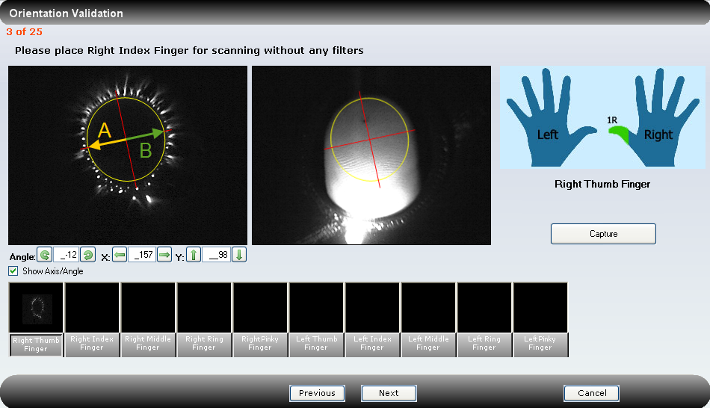

Horizontal radius A: ____________ cm
Horizontal radius B: ____________ cm

Verify that radius A is the same distance as radius B, within 0.1 centimeter:

Verified Not Verified Non-Conformance Ref. No.

Using a ruler, measure the distance from the center of the crosshairs to either side of the horizontal axis of the crosshairs on the live image. These are the horizontal radii C and D.

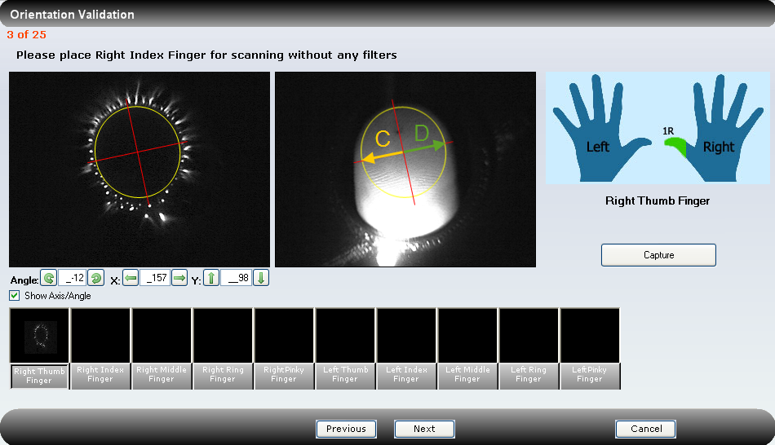

Horizontal radius C: ____________ cm
Horizontal radius D: ____________ cm

Verify that radius C is the same distance as radius D, within 0.1 centimeter:

Verified Not Verified Non-Conformance Ref. No.

Using a ruler, measure the distance from the center of the crosshairs to either side of the vertical axis of the crosshairs on the energized image. These are the vertical radii E and F.

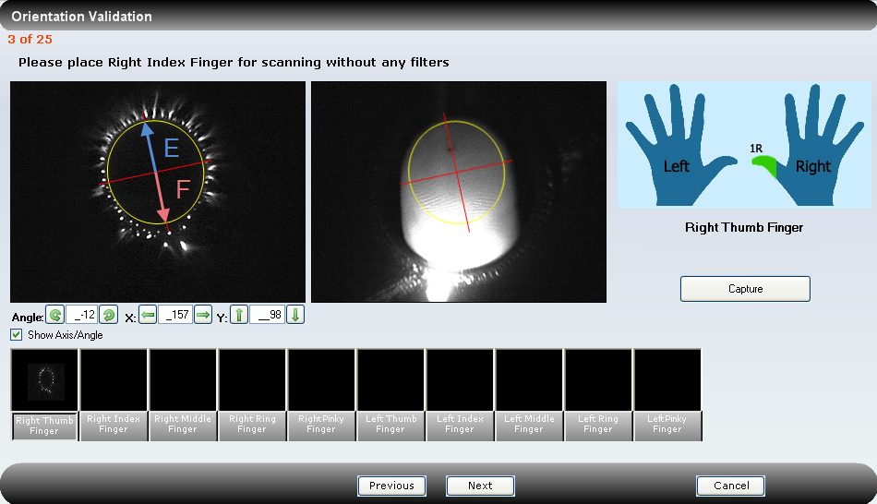

Vertical radius E: ____________ cm
Vertical radius F: ____________ cm

NOTE: The vertical radius is measured from the edge of the ellipse to the edge of the ellipse, not from the end of the line. The actual line is extended past the ellipse and the length of the line is not measured.

Verify that radius E is the same distance as radius F, within 0.1 centimeter:

Verified Not Verified Non-Conformance Ref. No.

Using a ruler, measure the distance from the center of the crosshairs to either side of the vertical axis of the crosshairs on the energized image. These are the vertical radii G and H.

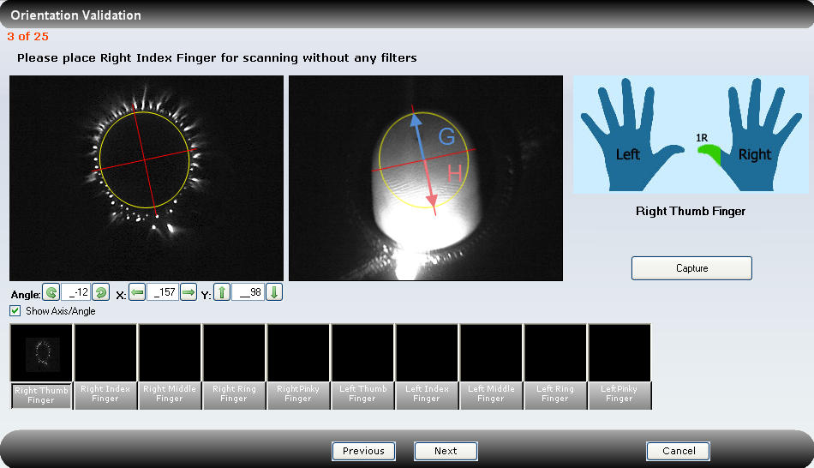

Vertical radius G: ____________ cm
Vertical radius H: ____________ cm

Verify that radius G is the same distance as radius H, within 0.1 centimeter:

Verified Not Verified Non-Conformance Ref. No.

Verify that that radii A/B and C/D are equivalent.

Verified Not Verified Non-Conformance Ref. No.

Verify that the radii E/F and G/H are equivalent.

Verified Not Verified Non-Conformance Ref. No.

To test the functionality of the orientation box arrows, click the right arrow next to the X: orientation box until the value in the X: orientation box is 260.
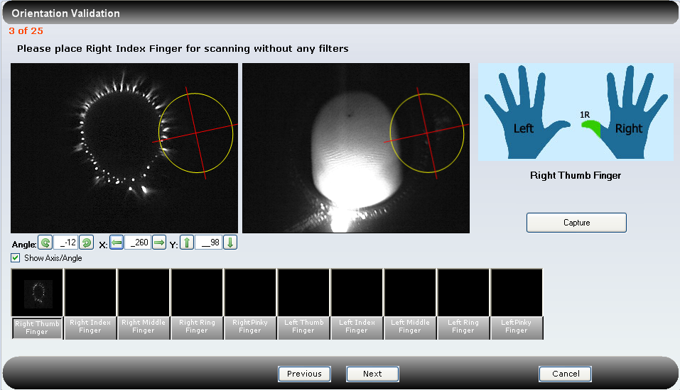

Verify that the ellipses on both the energized image and the still image move far to the right.

Verified Not Verified Non-Conformance Ref. No.

Click the left arrow next to the X: orientation box until the value in the X: orientation box is 60.
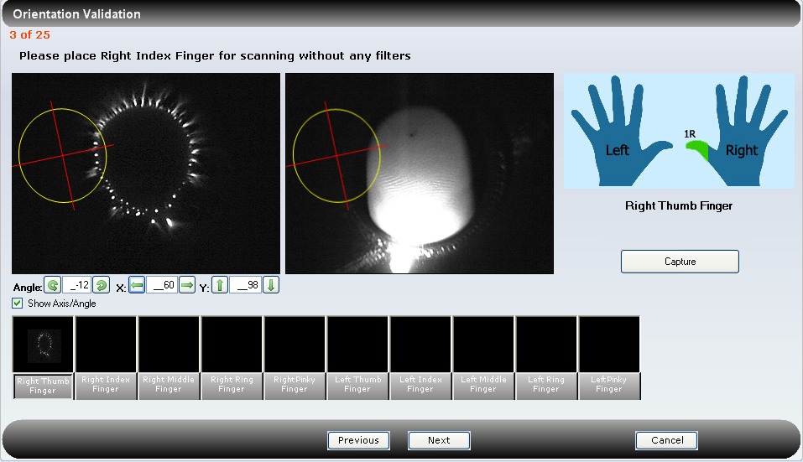
Verify that the ellipses on both the energized image and the still image move far to the left.

Verified Not Verified Non-Conformance Ref. No.

Click the right arrow next to the X: orientation box until the crosshairs return to the center of the images.
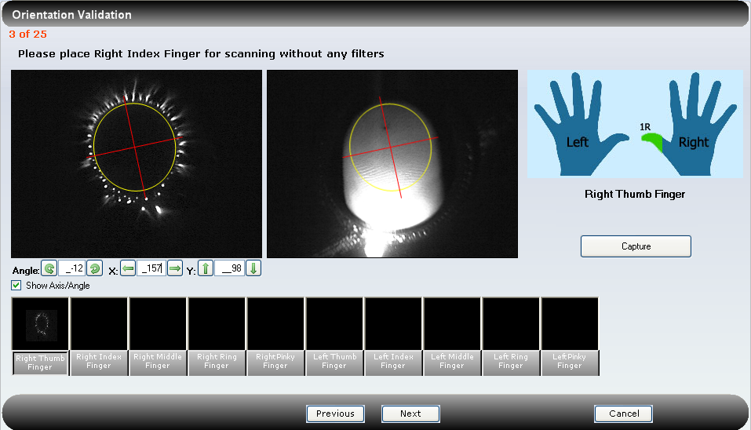
Verify that the ellipse moves back into the original centered position over the energized image and the lit image.

Verified Not Verified Non-Conformance Ref. No.

Click the up arrow next to the Y: orientation box until the value in the Y: orientation box is 60.
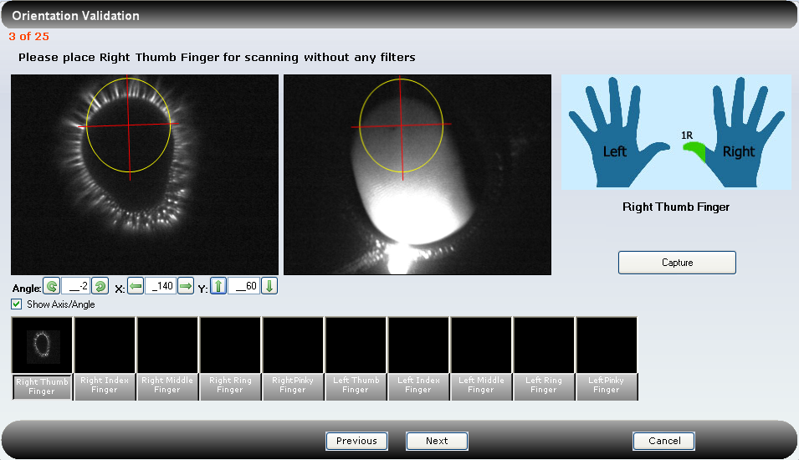

Verify that the ellipses on both the energized image and the still image move toward the top of the page.

Verified Not Verified Non-Conformance Ref. No.

Click the down arrow next to the Y: orientation box until the value in the Y: orientation box is 165.

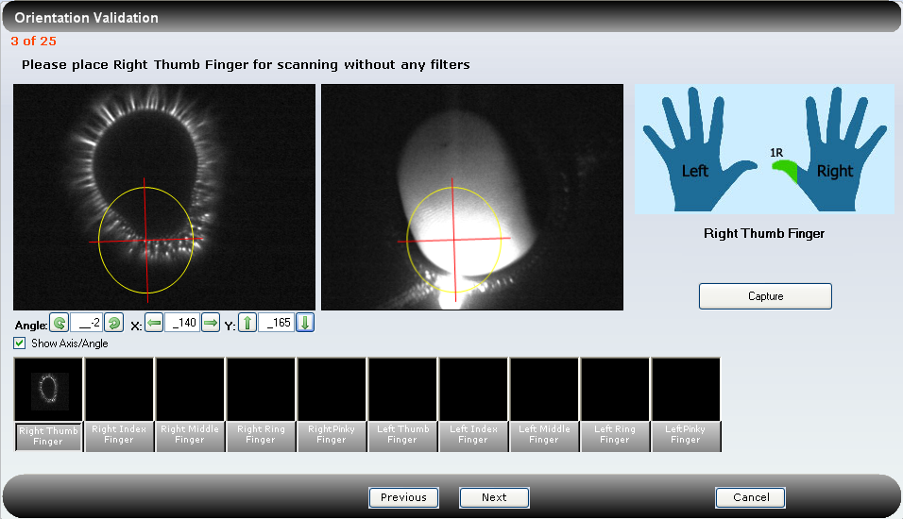

Verify that the ellipses on both the energized image and the still image move toward the bottom of the page.

Verified Not Verified Non-Conformance Ref. No.

Click the up arrow next to the Y: orientation box until the crosshairs return to the center of the images.
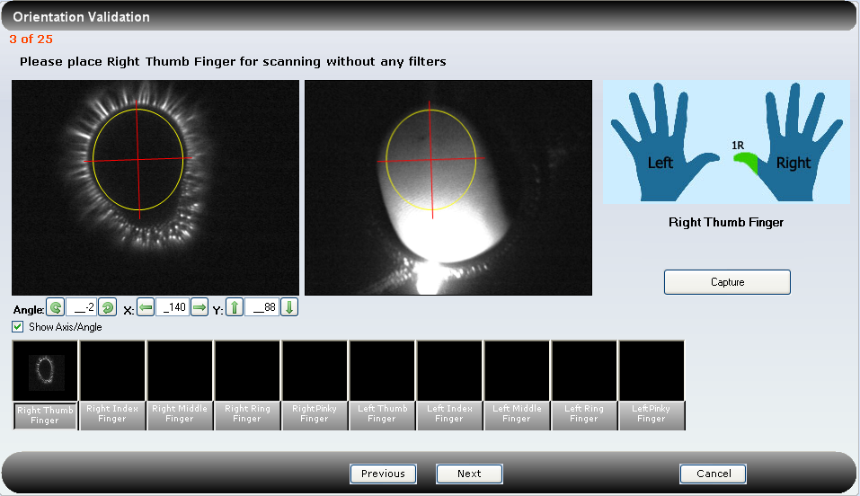
Verify that the ellipse moves back into the correctly centered position over the energized image and the lit image.

Verified Not Verified Non-Conformance Ref. No.

Record the automatically determined image angle, as listed in the angle orientation box.
Automatic angle: __________
Screen Protractor:
Use the Iconico Screen Protractor Version 4.0. (To download this screen tractor, go to http://www.iconico.com/protractor/.) To determine the version number, double click on the Screen Protractor desktop icon. Record the version listed:

Iconico Screen Protractor Version: _____________________
Use the screen protractor (to measure the angle of the vertical ellipse axis of the energized image (left box). Do so by placing the bullseye of the protractor over the center point of the ellipse. Align the reference line (darker, longer line) of the protractor at 90 degrees (straight up and down) and line up the other line on top of the vertical ellipse axis. Record the measured angle (to the nearest degree):
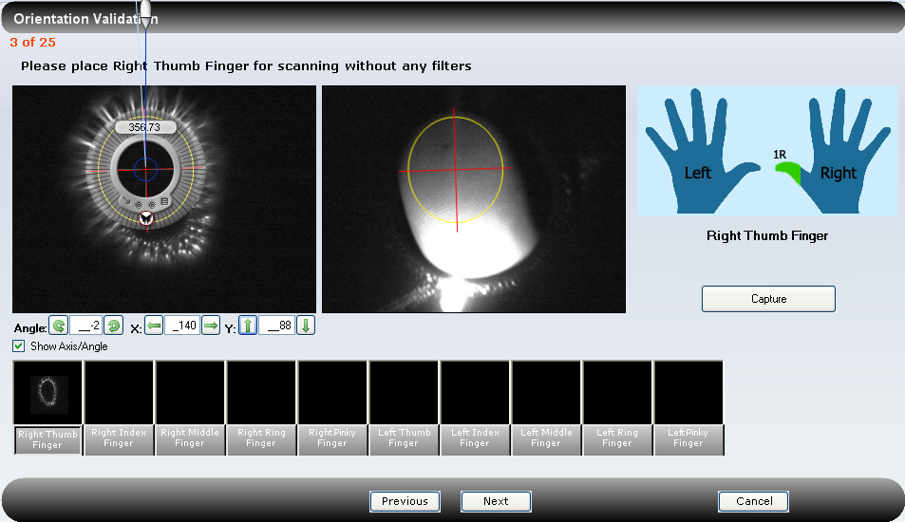
Measured energized image angle: ___________
Verify that the automatically assigned angle is within 2 degrees of the measured angle for the energized image.

Verified Not Verified Non-Conformance Ref. No.

Using the same procedure listed above, measure the angle of the vertical axis on the finger image (right box).
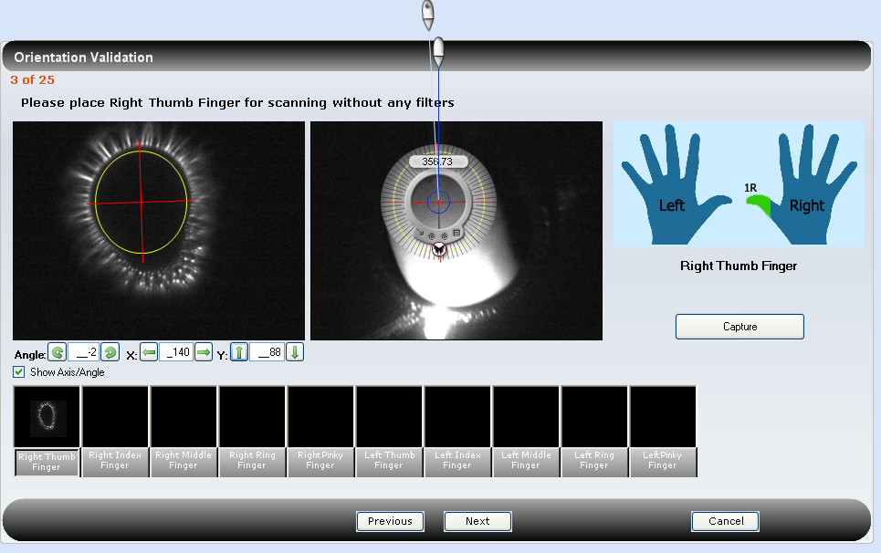
Measured finger image angle: ___________
Verify that the automatically assigned angle is within 2 degrees of the measured angle for the lit still image.
Click on the left rotation arrow next to the Angle: orientation box until the value in the box reads -40.
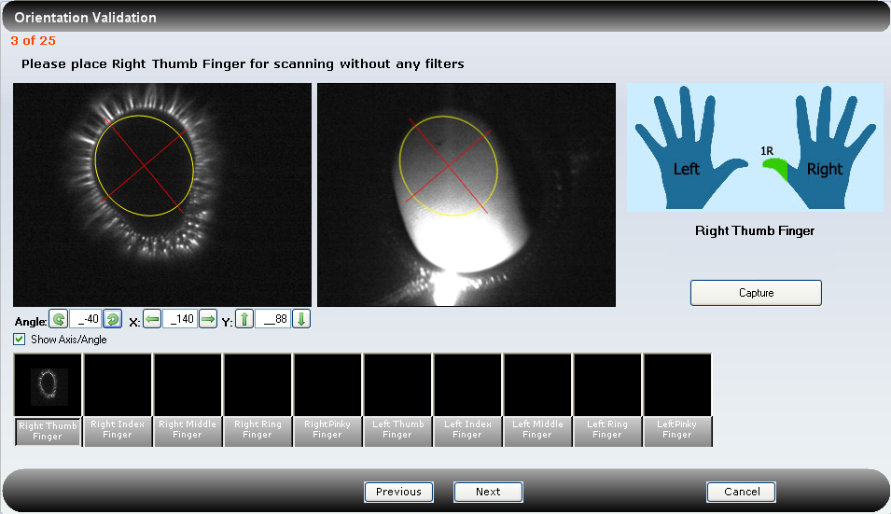
Verify that the ellipses on both the energized image and the still image rotate to the left.

Verified Not Verified Non-Conformance Ref. No.

Use the screen protractor to measure this new angle.

Measured angle: _____________

Verify that the angle measures within 2 degrees of -40.

Verified Not Verified Non-Conformance Ref. No.

Click in the angle rotation arrow until the angle is “0”.

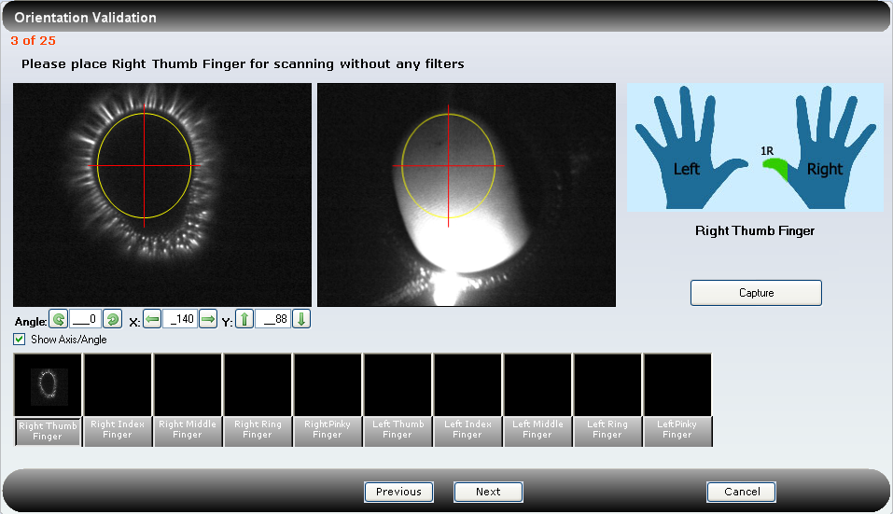

Verify that the vertical axes on both the energized image and the still image appear vertical.

Verified Not Verified Non-Conformance Ref. No.

Use the screen protractor to measure this new angle.
Measured angle: _____________
Verify that the angle measures within 2 degrees of zero.

Verified Not Verified Non-Conformance Ref. No.

Click on the right rotate button next to the angle orientation box until the box reads 55.
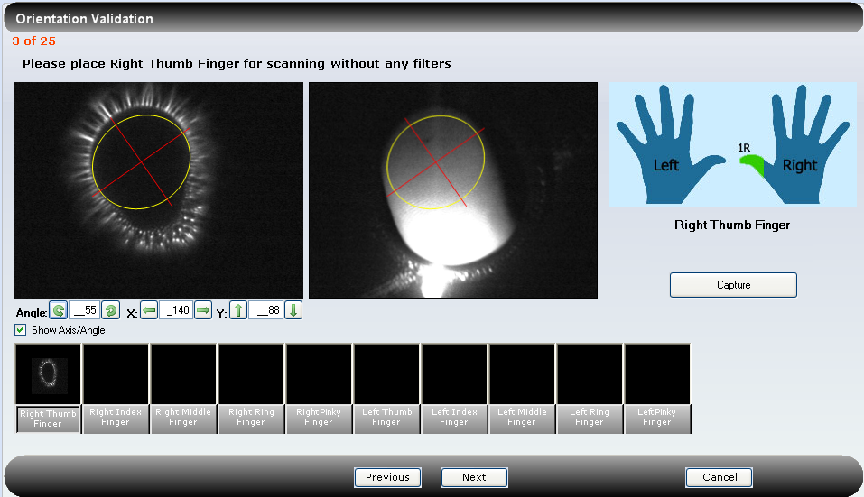
Verify that the ellipses on both the energized image and the still image rotate to the right.

Verified Not Verified Non-Conformance Ref. No.

Use the screen protractor to measure this new angle.
Measured angle: _____________
Verify that the angle measures within 2 degrees of 55.

Verified Not Verified Non-Conformance Ref. No.

Ensure that the subject’s finger is not resting on the glass and the calibration probe or other objects are not on the glass. Verify that the lit image of the finger remains visible in the right box.
Verified Not Verified Non-Conformance Ref. No.

Click on the Right Index Finger box.
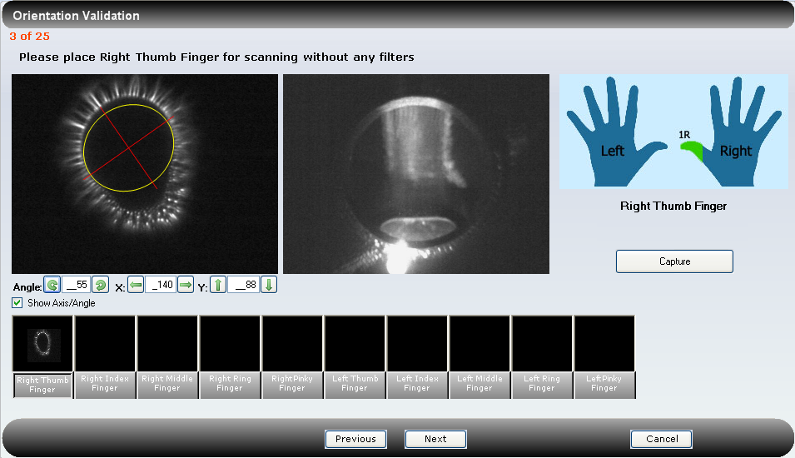
Verify that the lit image changes to a view of the inside of glass (without a finger in place) and the energized image remains the same, with the angle at 55 and the center point as what was determined correct via visual assessment (above).
Verified Not Verified Non-Conformance Ref. No.

Press the Capture Image button. Verify that the Captured Image box and the Finger Image box display the inside of the finger shroud and an ellipse with crosshairs, which may or may not be centered on the captured image.
Verified Not Verified Non-Conformance Ref. No.

Click the live preview button. Place a hand above the opening of the finger shroud to block the majority of the light. Press the Capture Image button. Verify that an error message “Unable to perform image calculations” appears. Click the OK button.
Verified Not Verified Non-Conformance Ref. No.

Click the “X” in the upper right corner of the New Capture tab, answer “yes” to the exit question, to return to the ClearView main screen.

- EPIC Administrator Challenges – Saving Calibration Data

  - Verification of the Calibration Data Storage to Temporary Files

The calibration data calculated during the calibration analysis is automatically stored by the software in a temporary location. This calibration information is temporarily stored whether or not the calibration was acceptable or failed. If a human subject is scanned, the calibration data is stored in the ClearView database associated with all human subjects scanned after the successful calibration and before the next successful calibration. If a human subject is not scanned, this calibration data is not stored in the ClearView database and, therefore, is not accessible to the EPIC Administrator. This challenge verifies that the save function works and that the new calibration analysis results are replaced after each analysis.

Click on the Settings button in the Application toolbar, and change the default calibration setting to be Configuration4. For Configuration4, change the value of Brightness to be “50” and the value of Gain to be “40”. Click on the Apply Settings button. Verify that the Settings tab closes and the screen returns to the ClearView main screen.

Verified Not Verified Non-Conformance Ref. No.

Click on the Camera Calibration button. Click on the Auto Calibration button in the lower right corner of the Scanner Calibration window. Verify that 5 warm-up images are taken followed by 1 image that is displayed in the thumbnail box. Verify that a message appears below the Scanner Calibration header notifying the user that the calibration process is progressing.

Verified Not Verified Non-Conformance Ref. No.

Upon completion of the calibration analysis, the Calibration Failure dialog box opens with the message “Unable to verify calibration images. Please, repeat calibration process.”

Verified Not Verified Non-Conformance Ref. No.

Click the OK button in the Calibration Failure dialog box. Click No when asked to save images.

Click the Close button at the bottom right of the Scanner Calibration window. Verify the Scanner Calibration window closes and the screen returns to the EPIC ClearView main screen.

Verified Not Verified Non-Conformance Ref. No.

Verify that the Alert box (located at the top of the screen) appears highlighted in red with the message “Calibration validation failed”.

Verified Not Verified Non-Conformance Ref. No.

Move the cursor into the Alert box and verify that the red highlight turns off.

Verified Not Verified Non-Conformance Ref. No.

Click on the View Selected icon. Verify that a list appears with columns for Time, Type, Title, and Message. In the message area, verify that there are entries that display values for the number of pixels and their status similar to the image below.

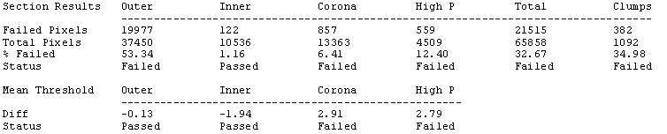
EXAMPLE ONLY

Verified Not Verified Non-Conformance Ref. No.

Verify that the View Alerts tab appears in the upper left corner of the screen.

Verified Not Verified Non-Conformance Ref. No.

Print the screen and label it “Cal A”. Sign and date the labeling. Click the “X” in the upper right corner of the View Alerts screen. Verify that the View Alerts tab closes and the screen returns to the ClearView main screen.

Verified Not Verified Non-Conformance Ref. No.

Click on the Settings button in the Application toolbar, and change the default calibration setting to be Configuration 2. Modify the values for Configuration 4 to Brightness of “90” and a Gain of “60”. Click on the Apply Settings button. Verify that the Settings tab closes and the screen returns to the ClearView main screen.

Verified Not Verified Non-Conformance Ref. No.

Click on the Camera Calibration button. Click on the Auto Calibration button in the lower right corner of the Scanner Calibration window. Verify that 5 warm-up images are taken followed by 1 image that is displayed in the thumbnail box. Verify that a message appears below the Scanner Calibration header notifying the user that the calibration process is progressing.

Upon completion of the calibration analysis, the Calibration Success dialog box opens with the message “The Calibration process was successful. Close this message to finalize the calibration data.

Verified Not Verified Non-Conformance Ref. No.

- License File Test
As of the 1.1.0.0 version of ClearView, a license key mechanism was implemented into the product, and the software will not operate without a valid license file present. The ClearView software now looks at start up for a file named “ClearView.lic” to be located in the same folder as the ClearView application itself. This file is a plain text file containing an encrypted string that represents the actual license structure. There are three licenses; Full, CV (cardiovascular), and Basic. One of these three license files is copied into the ClearView folder and renamed as “ClearView.lic” to set the license.

    - CV License

The following procedure will copy the CV license file into the ClearView folder to verify the report functionality of the ClearView software with the CV license.

Click on the Exit Icon to exit ClearView. Click on My Computer and locate folder O:\QualitySystems\Quality_System_Documents\Non-quality_system_records\2.0_Validation. Locate and select the file “ClearViewCV.lic” to copy (CTRL-C).

Right click on the ClearView icon on the desktop and click on Properties. A Properties window will open. Navigate to the folder identified in the “Start in:” field, and paste the “ClearViewCV.lic” file into this folder (CTRL-V). Locate and delete the “ClearView.lic” file in the same folder. Rename the “ClearViewCV.lic” file to “ClearView.lic”. This has now installed the basic license file for the ClearView software.

    - CV License – User Login – New Capture

Double click the EPIC ClearView icon on the desktop. Click in the Username box and enter “EPICUser”. Click in the password box and enter the password provided by the Network Administrator. The EPIC ClearView main screen is displayed.

Click on the New Capture button. Verify that the Search Patient window opens. Click the Find button at the top of the displayed window. Search and identify patient Epic Validation. Click to highlight this patient and click the New Capture button in the lower right corner of the window. Answer “No” to the 3 pre-scan questions that appear in the dialog and click “OK”. Verify that the New Capture tab opens and the “Gather a capture for” window is displayed.

Verified Not Verified Non-Conformance Ref. No.

Capture a full set of subject images by clicking into each finger image box of the Images without Capacitive Barrier row. Click the Capture Image button. Repeat the process until 10 Images without Capacitive Barrier and 10 Images with Capacitive Barrier have been captured. Verify that all twenty Images without Capacitive Barrier and Images without Capacitive Barrier image boxes contain energized images.

Verified Not Verified Non-Conformance Ref. No.

Click on the Submit for Analysis button in the lower right corner of the window. After processing, verify that a report appears on the screen under Print Report tab for EPIC Validation. Click on the ‘Print Report for’ tab.

Verified Not Verified Non-Conformance Ref. No.

Verify the report is five pages, page 1 contains explanations and Table 1, pages 2, 3 and 4 display Table 2 (containing organs and scores in the following order of Organ Systems: Cardiovascular; Respiratory; Gastrointestinal & Endocrine; Hepatic; and Renal and Reproductive), and page 5 contains definitions.

Verified Not Verified Non-Conformance Ref. No.

Click on the Report For Patient Name tab, then click on the System Comparison tab. Verify that a new section appears with two areas containing body side views, graphs, and organ names.

Verified Not Verified Non-Conformance Ref. No.

Click the “X” in the upper right corner of each tab. Verify each tab closes and the screen returns to the EPIC ClearView main screen.

Verified Not Verified Non-Conformance Ref. No.

    - CV License – Administrator Login – New Capture

Click the Change Login button. Click in the Username box and enter “Administrator”. Click in the password box and enter the password provided by the Network Administrator. The EPIC ClearView main screen is displayed.

Click on the New Capture button. Verify that the Search Patient window opens. Click the Find button at the top of the displayed window. Search and identify patient Epic Validation. Click to highlight this patient and click the New Capture button in the lower right corner of the window. Answer “No” to the 3 pre-scan questions that appear in the dialog and click “OK”. Verify that the New Capture tab opens and the “Gather a capture for” window is displayed.

Verified Not Verified Non-Conformance Ref. No.

Capture a full set of subject images by clicking into each finger image box of the Images without Capacitive Barrier row. Click the Capture Image button. Repeat the process until 10 Images without Capacitive Barrier and 10 Images with Capacitive Barrier have been captured. Verify that all twenty Images without Capacitive Barrier and Images without Capacitive Barrier image boxes contain energized images.

Verified Not Verified Non-Conformance Ref. No.

Click on the Submit for Analysis button in the lower right corner of the window. After processing, verify that a report appears on the screen under Print Report tab for EPIC Validation. Click on the ‘Print Report for’ tab.

Verified Not Verified Non-Conformance Ref. No.

Verify the report is five pages, page 1 contains explanations and Table 1, pages 2, 3 and 4 display Table 2 (containing organs and scores in the following order of Organ Systems: Cardiovascular; Respiratory; Gastrointestinal & Endocrine; Hepatic; and Renal and Reproductive), and page 5 contains definitions.

Verified Not Verified Non-Conformance Ref. No.

Click on the Biofield Analysis tab. Verify that a new screen appears with the Item Tab displayed on the left containing boxes for Indexes, Organ Systems, and Settings, a Magnified View tab (open) and an Admin View tab, and a visual representation of the body views.

Verified Not Verified Non-Conformance Ref. No.

Click on the Admin pages tab. Verify that the Raw Data sub tab is highlighted and a worksheet is displayed containing multiple columns and rows of data. Verify that the individual cells cannot be modified.

Verified Not Verified Non-Conformance Ref. No.

Click on the Raw Report sub tab. Verify that a worksheet is displayed with two tables containing multiple columns and rows of data. Verify that the individual cells cannot be modified.

Verified Not Verified Non-Conformance Ref. No.

Click on the Images without Capacitive Barrier sub tab. Verify that 10 scan images are displayed, labeled “Images without Capacitive Barrier”.

Verified Not Verified Non-Conformance Ref. No.

Click on the Toggle Sectors button in the lower left corner of the screen below the Images without Capacitive Barrier. Verify that the sector lines appear on each image. Click on the Toggle Sectors button again and verify that the sector lines disappear.

Verified Not Verified Non-Conformance Ref. No.

Click on the Images with Capacitive Barrier sub tab. Verify that 10 scan images are displayed, labeled “Images with Capacitive Barrier”.

Verified Not Verified Non-Conformance Ref. No.

Click on the Toggle Sectors button in the lower left corner of the screen below the Images with Capacitive Barrier. Verify that the sector lines appear on each image. Click on the Toggle Sectors button again and verify that the sector lines disappear.

Verified Not Verified Non-Conformance Ref. No.

Click on the Report For Patient Name, then click on the sub tab System Comparison. Verify that a new section appears with two areas containing body side views, graphs, and organ names.

Verified Not Verified Non-Conformance Ref. No.

Click the “X” in the upper right corner of each tab. Verify each tab closes and the screen returns to the EPIC ClearView main screen.

Verified Not Verified Non-Conformance Ref. No.

    - CV License – Administrator Login – View Capture Resubmit

Click the Search Capture button. Verify that the Search Capture window opens. Click on the Find button in the upper right corner of the displayed window. Search and identify patient Epic Validation. Click to highlight this patient and Treatment with a recent scan date, and click the View Capture button in the lower right corner of the displayed window. Verify that the View Capture tab is opened and the View Capture window is displayed. Verify that the Captured Image, the Finger Image, the ten Images without Capacitive Barrier and the ten Images with Capacitive Barrier are displayed.

Verified Not Verified Non-Conformance Ref. No.

Click the Resubmit Images for Analysis button in the lower left corner of the View Capture screen. Verify that after processing, a new screen appears with the Report For Patient Name tab data open and the ClearView Report is displayed.

Verified Not Verified Non-Conformance Ref. No.

Click on the ‘Print Report’ tab and verify the report is five pages, page 1 contains explanations and Table 1, pages 2, 3 and 4 display Table 2 (containing organs and scores in the following order of Organ Systems: Cardiovascular; Respiratory; Gastrointestinal & Endocrine; Hepatic; and Renal and Reproductive), and page 5 contains definitions.

Verified Not Verified Non-Conformance Ref. No.

Verify there are tabs for Admin Pages and Biofield Analysis and verify each tab contains the appropriate content per Section 6.5.

Verified Not Verified Non-Conformance Ref. No.

Click the “X” in the upper right corner of each tab and verify each tab closes and the screen returns to the EPIC ClearView main screen.

Verified Not Verified Non-Conformance Ref. No.

    - CV License – Administrator Login – New Capture Load Images Option

Click the New Capture Icon. Search the database for Epic Validation. Click the New Capture button. Answer “No” to the 3 pre-scan questions that appear in the dialog and click “OK”. Click in the box above Right thumb Finger box in the Images without Capacitive Barrier row. Right click and verify the Open window appears (a dialog box that allows you to locate the network file for loading of images).

Verified Not Verified Non-Conformance Ref. No.

Locate and open the following network folder:
I:\Clinical_Trials\HVS_Development_Folder\Subjects\HVS-1061\wofilter_021940. Click to highlight the 1R_wofilter image and click Open. Verify that the image is displayed in the Capture Image box and the Right Thumb Finger box in the Images without Capacitive Barrier row.

Verified Not Verified Non-Conformance Ref. No.

Repeat this step for all twenty images (2R, 3R, etc.) for both Images without Capacitive Barrier and Images with Capacitive Barrier (Images with Capacitive Barrier are located in the folder I:\Clinical_Trials\HVS_Development_Folder\Subjects\HVS-1061\wfilter).
Click on the Submit for Analysis button in the lower right corner of the window. After processing, verify that a new screen displays with the Report tab highlighted and the ClearView Report is displayed.

Verified Not Verified Non-Conformance Ref. No.

Click on the ‘Print Report’ tab and verify the report is five pages, page 1 contains explanations and Table 1, pages 2, 3 and 4 display Table 2 (containing organs and scores in the following order of Organ Systems: Cardiovascular; Respiratory; Gastrointestinal & Endocrine; Hepatic; and Renal and Reproductive), and page 5 contains definitions.

Verified Not Verified Non-Conformance Ref. No.

Verify there are tabs for Admin Pages and Biofield Analysis and verify each tab contains the appropriate content per Section 6.5.

Verified Not Verified Non-Conformance Ref. No.

Click the “X” in the upper right corner of each tab and verify each tab closes and the screen returns to the EPIC ClearView main screen.

Verified Not Verified Non-Conformance Ref. No.

    - Basic License

The following procedure will copy the basic license file into the ClearView folder to verify the report functionality of the ClearView software with the basic license.

Click on the Exit Icon to exit ClearView. Click on My Computer and locate folder O:\QualitySystems\Quality_System_Documents\Non-quality_system_records\2.0_Validation. Locate and select the file “ClearViewBasic.lic” to copy (CTRL-C).

Right click on the ClearView icon on the desktop and click on Properties. A Properties window will open. Navigate to the folder identified in the “Start in:” field, and paste the “ClearViewBasic.lic” file into this folder (CTRL-V). Locate and delete the “ClearView.lic” file in the same folder. Rename the “ClearViewBasic.lic” file to “ClearView.lic”. This has now installed the basic license file for the ClearView software.

    - Basic License – User Login – New Capture

Double click the EPIC ClearView icon on the desktop. Click in the Username box and enter “EPICUser”. Click in the password box and enter the password provided by the Network Administrator. The EPIC ClearView main screen is displayed. Click on the New Capture button. Verify that the Search Patient window opens. Click the Find button at the top of the displayed window. Search and identify patient Epic Validation. Click to highlight this patient and click the New Capture button in the lower right corner of the window. Answer “No” to the 3 pre-scan questions that appear in the dialog and click “OK”. Verify that the New Capture tab opens and the “Gather a capture for” window is displayed.

Verified Not Verified Non-Conformance Ref. No.

Capture a full set of subject images by clicking into each finger image box of the Images without Capacitive Barrier row. Click the Capture Image button. Repeat the process until 10 Images without Capacitive Barrier and 10 Images with Capacitive Barrier have been captured. Verify that all twenty Images without Capacitive Barrier and Images without Capacitive Barrier image boxes contain energized images. Note: calibration images should not be used as they may cause a matlab error, therefore, human subject images should be used.

Verified Not Verified Non-Conformance Ref. No.

Click on the Submit for Analysis button in the lower right corner of the window. After processing, verify that a report appears on the screen under Report tab for EPIC Validation.

Verified Not Verified Non-Conformance Ref. No.

Verify that there are only two tabs available, Report For Patient Name and Print Report For Patient Name. Verify that the Print Report displays columns for Measurement Point with finger descriptions, Left and Right Physical and Left and Right Autonomic scores. The Measurement Point column should consist of rows labeled Thumb #1 thru Thumb #9, Index #1 thru Index #10, Middle #1 thru Middle #9, Ring #1 thru Ring #9, and Pinky #1 thru Pinky #9. The scores data should consist of numbers from 0 thru 25, and some positions that are blank. Click the “X” at the far right of the Print Report subtab to return to the ClearView main screen. Click the Exit icon. Verify that the ClearView software closes and the desktop appears.

Verified Not Verified Non-Conformance Ref. No.

    - Basic License – Administrator Login – New Capture

Double click the EPIC ClearView icon on the desktop. Click in the Username box and enter “administrator”. Click in the password box and enter the password provided by the Network Administrator. The EPIC ClearView main screen is displayed. Click on the New Capture button. Verify that the Search Patient window opens. Click the Find button at the top of the displayed window. Search and identify patient Epic Validation. Click to highlight this patient and click the New Capture button in the lower right corner of the window. Answer “No” to the 3 pre-scan questions that appear in the dialog and click “OK”. Verify that the New Capture tab opens and the “Gather a capture for” window is displayed.

Verified Not Verified Non-Conformance Ref. No.

Capture a full set of subject images by clicking into each finger image box of the Images without Capacitive Barrier row. Click the Capture Image button. Repeat the process until 10 Images without Capacitive Barrier and 10 Images with Capacitive Barrier have been captured. Verify that all twenty Images without Capacitive Barrier and Images without Capacitive Barrier image boxes contain energized images. Note: calibration images should not be used as they may cause a matlab error, therefore, human subject images should be used.

Verified Not Verified Non-Conformance Ref. No.

Click on the Submit for Analysis button in the lower right corner of the window. After processing, verify that a report appears on the screen under Report tab for EPIC Validation.

Verified Not Verified Non-Conformance Ref. No.

Verify that there are only two tabs available, Report For Patient Name and Print Report For Patient Name. Verify that the Print Report displays columns for Measurement Point with finger descriptions, Left and Right Physical and Left and Right Autonomic scores. The Measurement Point column should consist of rows labeled Thumb #1 thru Thumb #9, Index #1 thru Index #10, Middle #1 thru Middle #9, Ring #1 thru Ring #9, and Pinky #1 thru Pinky #9. The scores data should consist of numbers from 0 thru 25, and some positions that are blank. Click the “X” at the far right of the Print Report subtab to return to the ClearView main screen.

Verified Not Verified Non-Conformance Ref. No.

    - Basic License – Administrator Login – View Capture Resubmit

Click the Search Capture button. Verify that the Search Capture window opens. Click on the Find button in the upper right corner of the displayed window. Search and identify patient Epic Validation. Click to highlight this patient and Treatment with a recent scan date, and click the View Capture button in the lower right corner of the displayed window. Verify that the View Capture tab is opened and the View Capture window is displayed. Verify that the Captured Image, the Finger Image, the ten Images without Capacitive Barrier and the ten Images with Capacitive Barrier are displayed.

Verified Not Verified Non-Conformance Ref. No.

Click on the Resubmit for Analysis button in the lower right corner of the window. After processing, verify that a report appears on the screen under Report tab for EPIC Validation.

Verified Not Verified Non-Conformance Ref. No.

Verify that there are only two tabs available, Report For Patient Name and Print Report For Patient Name. Verify that the Print Report displays columns for Measurement Point with finger descriptions, Left and Right Physical and Left and Right Autonomic scores. The Measurement Point column should consist of rows labeled Thumb #1 thru Thumb #9, Index #1 thru Index #10, Middle #1 thru Middle #9, Ring #1 thru Ring #9, and Pinky #1 thru Pinky #9. The scores data should consist of numbers from 0 thru 25, and some positions that are blank. Click the “X” at the far right of the Print Report subtab to return to the ClearView main screen.
Verified Not Verified Non-Conformance Ref. No.

    - Basic License – Administrator Login – New Capture Load Images Option

Click the New Capture Icon. Search the database for Epic Validation. Click the New Capture button. Answer “No” to the 3 pre-scan questions that appear in the dialog and click “OK”. Click in the box above Right thumb Finger box in the Images without Capacitive Barrier row. Right click and verify the Open window appears (a dialog box that allows you to locate the network file for loading of images).
Verified Not Verified Non-Conformance Ref. No.

Locate and open the following network folder:
I:\Clinical_Trials\HVS_Development_Folder\Subjects\HVS-1061\wofilter_021940. Click to highlight the 1R_wofilter image and click Open. Verify that the image is displayed in the Capture Image box and the Right Thumb Finger box in the Images without Capacitive Barrier row.
Verified Not Verified Non-Conformance Ref. No.

Repeat this step for all twenty images (2R, 3R, etc.) for both Images without Capacitive Barrier and Images without Capacitive Barrier (Images with Capacitive Barrier are located in the folder I:\Clinical_Trials\HVS_Development_Folder\Subjects\HVS-1061\wfilter).
Click on the Submit for Analysis button in the lower right corner of the window. After processing, verify that a report appears on the screen under Report tab for EPIC Validation.

Verified Not Verified Non-Conformance Ref. No.

Verify that there are only two tabs available, Report For Patient Name and Print Report For Patient Name. Verify that the Print Report displays columns for Measurement Point with finger descriptions, Left and Right Physical and Left and Right Autonomic scores. The Measurement Point column should consist of rows labeled Thumb #1 thru Thumb #9, Index #1 thru Index #10, Middle #1 thru Middle #9, Ring #1 thru Ring #9, and Pinky #1 thru Pinky #9. The scores data should consist of numbers from 0 thru 25, and some positions that are blank. Click the “X” at the far right of the Print Report subtab to return to the ClearView main screen.
Verified Not Verified Non-Conformance Ref. No.

    - Restore Full License

The following procedure will copy the full license file into the ClearView folder to verify the full report functionality of the ClearView software has been restored.

Click the “X” in the upper right corner of the report tab to return to the ClearView main screen. Click on the Exit Icon to exit ClearView. Click on My Computer and locate folder O:\QualitySystems\Quality_System_Documents\Non-quality_system_records\2.0_Validation. Locate and select the file “ClearViewFull.lic” to copy (CTRL-C).

Right click on the ClearView icon on the desktop and click on Properties. A Properties window will open. Navigate to the folder identified in the “Start in:” field, and paste the “ClearViewFull.lic” file into this folder (CTRL-V). Locate and delete the “ClearView.lic” file in the same folder. Rename the “ClearViewFull.lic” file to “ClearView.lic”. This has now installed the full license file for the ClearView software.

Double click the EPIC ClearView icon on the desktop. Click in the Username box and enter “Administrator”. Click in the password box and enter the password provided by the Network Administrator. The EPIC ClearView main screen is displayed.

Click the View Report icon. Click Display Report. Type “Epic” in the first name box of the Search Capture box. Click Find. Highlight the patient name Epic Validation. Click View Report button. Verify that a report appears on the screen under the Report tab for EPIC Validation.

Verified Not Verified Non-Conformance Ref. No.

Verify the Print Report is five pages, page 1 contains explanations and Table 1, pages 2, 3 and 4 display Table 2 (containing organs and scores in the following order of Organ Systems: Sensory and Skeletal; Hepatic, Cardiovascular; Respiratory; Gastrointestinal & Endocrine; and Renal and Reproductive Systems), and page 5 contains definitions.

Verified Not Verified Non-Conformance Ref. No.

Verify there are tabs for Admin Pages and Biofield Analysis and verify each tab contains the appropriate content per Section 6.5.

Verified Not Verified Non-Conformance Ref. No.

Click the “X” in the upper right corner of each tab and verify each tab closes and the screen returns to the EPIC ClearView main screen. Click the Exit button. Verify the ClearView software closes and the desktop appears.

Verified Not Verified Non-Conformance Ref. No.

    - Automatic Reconnection Attempts

The ClearView software now has the capability to potentially automatically reconnect to the scanner in the event that the communication link between the computer and the scanner are lost. *** This does not include the disconnection event that occurs when USB cables are physically removed; physical removal of cables should not be done during this test of at any other time.

Log into the ClearView application as ‘Administrator’ and click on the ‘New Capture’ button. Search for an existing user in the system and click the ‘New Capture’ button at the bottom of the search results page. Answer “No” to the 3 pre-scan questions that appear in the dialog and click “OK”. This should cause the Gather Capture dialog to appear.

Verified Not Verified Non-Conformance Ref. No.

Click the ‘Capture Image’ button and verify that an image can in fact be captured by the system.

Verified Not Verified Non-Conformance Ref. No.

Reach around to the back of the scanner and flip the power switch up (to the off position). Attempt to capture an image by clicking on the ‘Capture Image’ button. No sound should be heard and after about 20-30 seconds, the following dialog may appear, or you may just get a blank image.

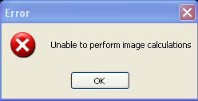

Click on the ‘Ok’ button to have the dialog disappear.

Verified Not Verified Non-Conformance Ref. No.

Now flip the power switch down (turning the scanner back on) and wait for about 10 -30 seconds. Click on the ‘Capture Image’ button and verify that an image is captured and displayed.

Verified Not Verified Non-Conformance Ref. No.

Exit out of the capture and out of ClearView.

- Reference

EG-011, Software Validation
QA-004, Deviations
CS-003, Customer Feedback

- Attachments

Attachment A, Deviations from Protocol
Attachment B, Non-conformances Worksheet

Attachment A
Deviations from Protocol
NOTE: This form is used for minor deviations from the protocol as written. Fill out all sections of this form prior to moving forward in the validation process.
No. | Date | Name | Description of Deviation (include reference to the protocol section) | Resolution/Action Taken | Reviewed

Attachment B
Non-conformances Worksheet
NOTE: This form is used for all protocol steps which did not perform as expected. Fill out all sections of this form prior to moving forward in the validation process.
No. | Date | Name | Description of Non-conformance (include reference to the protocol section) | Resolution/Action Taken

